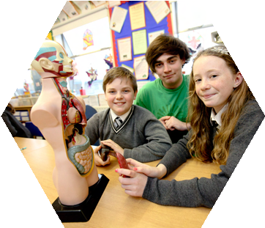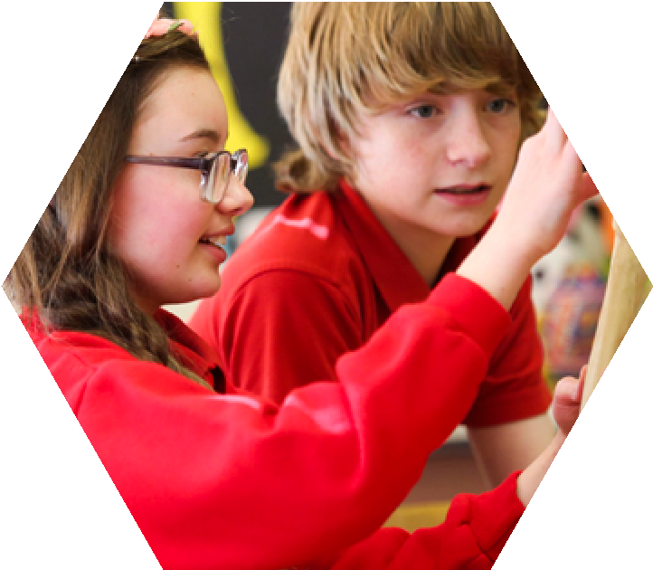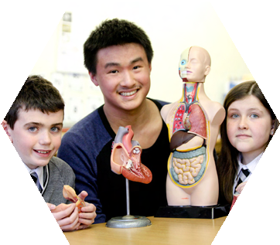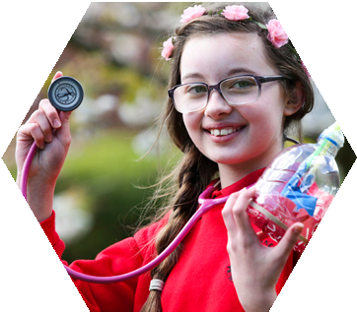

**Medics in Primary Schools**

**2024 - 25: Online Version**

**A QUEEN’S UNIVERSITY / SENTINUS PROGRAMME**

Medics

in Primary Schools

Contents

**Background and Introductions.………..………...3**

**Online Learning ……………………………………….20  
Healthy Body…………………………………………..44  
Healthy Heart and Lungs…………………………..64  
Healthy Skin……………………………………………75**

**Assessment Appendix ……………..……………...84**

**Welcome**

The Medics in Primary School (MIPS) programme has been running for over twenty years, and during that time it has provided medical students with a unique opportunity to develop and enhance their communication and teaching skills.

In their document *Outcomes for Graduates*, the General Medical Council explains that all new qualified doctors should be able to “Communicate clearly, sensitively and effectively with individuals and groups regardless of their age”. This may involve conveying complex information in a sensitive and jargon-free manner at an appropriate pace. As a paediatrician, I am particularly eager that students learn to talk and listen to children.

Integral components of the MIPS programme include the opportunity for the medical students to prepare educational sessions (which need to be pitched at the right level), to be observed, and to be provided with constructive feedback in relation to their educational delivery and communication skills - all of these are essential parts of the learning cycle.

I wish you all every success and hope that the knowledge and skills which you acquire during this programme will provide you with a solid foundation for the rest of your undergraduate studies and your future careers. Enjoy this excellent SSC.

**Professor Neil Kennedy**

**Deputy Head of the School of Medicine, Dentistry and Biomedical Sciences**

QUB Contacts:

**Miss Mairead Boohan** Email: [m.boohan@qub.ac.uk](mailto:m.boohan@qub.ac.uk) Telephone: 028 9097 2467

**Prof Bronagh Blackwood** Email: [b.blackwood@qub.ac.uk](mailto:b.blackwood@qub.ac.uk) Telephone: 028 9097 6379

**Programme Background**

The *Medics in Primary Schools* (MIPS) programme provides an opportunity for primary school pupils and medical students to develop their communication skills. The programme, which has been operating since 2001, has involved over 1000 medical students at Queen’s University Belfast, working face to face in schools with over 20,000 primary pupils at 65 primary schools in the Greater Belfast area. Since 2021, about 40 schools have also participated online. The programme is offered as a Student Selected Component within medical students’ second year course.

Students have a placement one session a week for up to eight weeks in the autumn semester in a primary school, during which they deliver a science and health education programme to upper primary pupils, and develop their own communication skills in working with young people. Their delivery is either face to face in schools in the Greater Belfast area or, in your case, online in schools which are inconveniently far from the University.

**The MIPS Programme:**The main aims of *Medics in Primary Schools* are:

*1. to enrich the teaching and learning of health education in primary schools,*

*2. to provide young role models in the classroom, and raise awareness of the work of medical professionals*

*3. to improve communication between medics and young people*

See the Learning Outcomes on page 10 for more detailed objectives, specified by the QUB School of **Medicine,** Dentistry and Biomedical Sciences.

The programme was developed by local educators, with the support of former Education and Library Board advisers, and reflects the Key Stage 2 programme of the Northern Ireland Curriculum. Students are provided with teaching and learning material and a Guide to using virtual learning resources. Each of three teaching units comprises a two to four week outline course that can be presented as a whole, or amended to suit students’ expertise and the needs of the school. These units are *Healthy Body, Healthy Heart and Lungs, and Healthy Skin*.

During their Introductory Week students are asked to select, with their teachers, elements of the units in the Guide that they should cover. Class teachers may have already taught some elements: however, they may ask students to cover these again for reinforcement, or they may be satisfied with what has been already taught.

This Guide material is advisory: students are encouraged to follow their own special medical interests when they feel pupils would welcome and can cope with this. Emphasis is very much on practical and investigative aspects of each theme. Teachers are encouraged to be proactive in their help and support of the student. The programme works because teachers like it, understand it, and become involved. Students are encouraged to ask for comment on their work and their developing pedagogic skills. Email feedback from teachers is actively encouraged: a response sheet is provided on the MiPS area of the Sentinus website, [www.sentinus.co.uk](http://www.sentinus.co.uk).

**The Medical Students**: Every second-year medical student at Queen’s University is offered MiPS as a Student Selected Component, covering two sessions a week during their first semester (September – January). One session each week is spent either in school or online, the other is for research of resources, and lesson preparation. Students who choose MIPS are given training in working with upper primary pupils, and deliver a science and health education programme to their partner school. They receive this *Student Teaching and Learning Guide* detailing the material they may wish to teach, and ways are suggested through which the programme might be delivered. There are two versions of the Guide, one for students working online, the other for students working in schools.  You will use the online Guide. However, you can access the in-school Guide on the MIPS area of the Sentinus website: [www.sentinus.co.uk](http://www.sentinus.co.uk), Follow Programmes, then Primary and (page 2) Medics in Primary Schools. Additional resources (listed on page 13 of this Guide) are also available on the MIPS area of the Sentinus website.

Finally, students are assessed on their developing pedagogic skills during the programme. Electronic logbooks (online and in-school) are available on the MiPS area of the Sentinus website to record reflections on their experiences. This is not assessed, but noting important incidents and reflections as they happen, rather than trying to remember them later, can be a useful basis for their reflective commentary.

**The Pupils:**  About forty primary schools in the Belfast area and further afield in the Province enthusiastically engage in the programme each year. Pupils look forward to the ‘young doctor’ working with them each week. Their response is very positive: some see the student as a role model for them in considering potential careers in medicine or other health-related areas.

**The Teachers:** During the early autumn the Programme Manager, Peter Mc Alister, contacts principals of potential schools outlining the advantage to the school of participation, together with the schools’ responsibilities. This is particularly useful for schools new to the programme. Teachers from participating schools also receive this Guide, and the course materials are available on the MIPS area of the Sentinus website. Teachers are encouraged to develop their mentoring skills with young students who do not intend to become teachers, but who do wish to develop their communication skills.

**For Principals and Mentoring Teachers**

Once again Queen's University and Sentinus are working in partnership to enable the *Medics in Primary Schools* (MIPS) initiative to run in the autumn semester, 2024 - 25. About seventy medical students will be taking part. About forty schools, with about 2000 pupils, will participate in the programme. Most of these schools have taken part before, some as many as twenty times. Two parallel programmes are provided, one in-school for schools in the Greater Belfast area within easy travelling distance from QUB, the other online for selected schools further from QUB.

For schools new to the project, and to those returning schools, I would like to say *Welcome*, and thank you for your willing cooperation. Your ability to make medical students feel comfortable, and benefit hugely from the experience, will be much appreciated by all involved in the organisation and management of the programme.

This programme succeeds only if the teacher and student are working together. We are not trying to produce new teachers, and the medical students may not have all the teaching skills that student teachers might have. The student has to co-operate with, and have the co-operation of, the teacher with whom she or he is working. Otherwise the programme does not succeed.

**Feedback**, positive and constructively critical, from the teacher, is essential. Feedback is a mechanism by which we all learn, and is much appreciated by the students. It would be useful for you to congratulate the student on her / his performance, identifying positive points, but also importantly to identify points for improvement and offer appropriate advice. Feedback by email would be very welcome. A form for email feedback is provided on the MiPS area of the Sentinus website [www.sentinus.co.uk](http://www.sentinus.co.uk).

In collaboration between Queen’s University and Sentinus, the plan of the MiPS online programme is to allocate a student to each participating school to teach a series of virtual lessons. Students will:

- attend a **Training Session** at QUB in mid October. (See the MiPS Student Programme on page 6).

- teach lessons at times to be agreed with the school beginning with a **Student Introductory Session** the following week (depending on the date of the school’s half-term break). Ideally there will follow eight or nine teaching sessions for each school, probably beginning after their school’s autumn half-term break and ending in late January.

- introduce each session with a practical demonstration and a plenary session in which the children will participate with the assistance of the teacher.

- possibly ask the class to carry out a practical activity (easily resourced) at home before the next class with the student, and discuss the outcomes at the next session.

- attend a **mid Programme Review** at QUB in mid December.

- submit a **Reflective Commentary** by mid February,

The target Year Group is Key Stage 2, preferably Primary 6 or 7 because of the complexity of the content, and schools may organise classes and / or groups in whatever way suits their circumstances. It is essential for continuity purposes to select the same cohort for the complete programme.

Students will be asked to make the basis of their lessons as practical as possible, and not teach mainly through lectures.

The formal assessment process (see pages 84 - 95) is built into the programme and, for this to be successful, we need your co-operation. Students say that they would welcome some overall evaluation of their teaching. The teacher response form (page 94) has been introduced as a result of student feedback. This format is modified from a list of *Competences for Beginning Teachers,* used in initial teacher training. In order to give you as little extra work as possible the form has a series of tick boxes and there is a space for you to add a professional comment at the end. The assessment form and instructions for use will be distributed to each school during the programme.

Students can access to a logbook to record their experiences. This is provided, in both online and in-school formats, in the MiPS area of the Sentinus website [www.sentinus.co.uk](http://www.sentinus.co.uk). They are encouraged to contribute to this as a foundation for their assessed reflective commentary. In previous years we have found that some students use the logbook either intermittently or not at all. In order to encourage them to make full use of the logbook we are asking you to sign off each unit as completed.

**A student should never be left alone with a class.**

I must emphasise this: if an accident were to occur with only an unqualified person in charge, there may be insurance issues and the school would have difficulty in refuting charges of abdication of responsibility.

**Please also note that students are prohibited from using animal parts in any demonstration to pupils.**

Finally, may I once again emphasise to principals and teachers that, in the event that the student is not performing in the way the school would expect, I should be contacted. I promise action will be taken to remedy the situation.

My contact details are:

**Peter Mc Alister**

**Telephone: 028 9061 4271 Mobile: 07896 953848 Email:** [**ppmcalister@gmail.com**](mailto:ppmcalister@gmail.com)

**For Students**

**Your MiPS Timetable 2024 - 25**

Afternoon Training Sessions 2.00 – 3.30 Monday 14 and Tuesday 15 October

Student Introductory Sessions Monday 21, Tuesday 22 and Thursday 24 October

Mid Programme Reviews 10.00 – 11.30 Thursday 12 December

Final School Visits Week of Monday 27 January

Reflective Commentary Submission Deadline Midnight, Tuesday 4 February

Welcome to MIPS, the *Medics in Primary Schools* programme. You will spend a morning or afternoon a week during most of the next three months presenting electronically a relevant and interesting health education programme to a group of upper primary pupils. Your role will be to help develop their knowledge and understanding of their bodies and how to look after them, and to let them see you as a potential model for what they might be doing in ten years’ time.

During your time in contact with your school you will probably be working with a Year 6 or Year 7 class, though you may be asked to work with younger pupils, possibly in a composite class, within Key Stage 2 (ages 8 – 11).

**You will not have to teach the class alone: there must be a teacher in your classroom at all times.**

The role of the class teacher will be to support you, apply discipline if necessary, and to observe your activity in order to provide you with the essential feedback you need to develop your teaching capability*.*

You will present material to the class once each week, either a Monday or Tuesday afternoon or a Thursday morning depending on the school timetable.  Your other session each week is for research of resources and lesson preparation. Your lesson should be designed to include a class experiment or practical demonstration and a plenary session during which the children will participate. You may also ask the class to carry out a practical activity at home before your next session. You can discuss the outcomes at the next session.

Training meetings are at Queen’s University in mid-October. In these you will be introduced to the units of MiPS and be given an indication of what you need to know about current primary school education, and how it has changed since your time there.

From the following week you will be introduced to the pupils, with your teacher as an active supporter in class, and responsible for keeping the class under control. You should arrange to discuss with your teacher the units or parts of units (detailed on pages 44 – 82 of this Guide), which you will cover later in the programme. Ask about the procedure for printing photocopies of material you may wish to use. Also decide with your class teacher how pupils should address you in class: first name or surname.  As you teach these units, feedback is essential if you are to improve your teaching skills and capabilities: you should set up a procedure for your teacher to comment constructively on your teaching if this is not done automatically. Suggest that your teacher emails a few notes of comment after each session. A form for email feedback is provided on the MiPS area of the Sentinus website [www.sentinus.co.uk](http://www.sentinus.co.uk).

In your first, introductory, teaching session, you should be given an opportunity to introduce yourself more formally. We ask you to design your own Powerpoint slides to present in this session. Your initial slide should have the title *Medics in Primary Schools* at the top and should also include the logos of MIPS’ supporters: Queen’s University Belfast and Sentinus. These logos can be copied from the training Powerpoint presentation on the MiPS area of the Sentinus website. Below is suggested text for your presentation – the main questions are in bold – and some of the information you may wish to disclose follows each question:

**1. Who am I?** Your background, where you live, your school education: how you got from primary school to where you are now, what you do in your spare time. Possibly include a portrait photograph.

**2. What do I do at Queen’s?** Your university course, why you chose it, what you plan to do in future.

**3. Where do I study?** Where the School of Medicine is, who goes to it, how you can become a student.

**4. Why am I presenting this material?** To teach science and health education, to learn from teacher and pupils, to answer pupils’ questions.

**5. When will I be presenting this material?** Day, time, duration and type of online lessons in MIPS.

Encourage pupils to ask you questions: they learn more effectively this way. You should feel comfortable with what information you disclose. Do be aware that although you are informing the pupils you should be discreet, particularly about yourself.

To help ensure that this is a dialogue rather than just a formal presentation, teachers should have asked their pupils to prepare some relevant questions in advance, and these can be taken at appropriate points. You might like to ask each pupil to bring in a medical question they would like answered. You could then cover these either at the beginning of a session, or at an appropriate point later in your teaching. But check with your class teacher that these questions and your proposed answers won’t be embarassing to members of the class.

In your introductory session, you may also find it useful to ask the school to provide pupils with large (preferably A4) sticky labels, and ask pupils to write their first names in very large letters in felt tip, so that you can read the labels and address individual pupils personally. This makes for more effective communication.

**Mid-Programme Reviews** have been arranged at Queen’s University for mid-December. Questionnaires will be circulated in advance, asking for your comments on the general administration of the MiPS programme and on this Guide. Summaries of responses will be presented at the Reviews. Your **Reflective Commentary** will be expected in mid-February.

**Useful Websites**

As the pupils will see you as a medical expert, you are likely to be asked medically related questions outside the scope of this Guide. We encourage you to respond within your expertise to questions on these and similar topics if they arise. The following websites relating to topics raised in previous years are useful starting points and were correct and active in August 2024. They are for your information. Check with your class teacher if you intend to use any of them in class.

- **Antimicrobial Resistance** [www.nhs.uk/NHSEngland/ARC/Pages/AboutARC.aspx](http://www.nhs.uk/NHSEngland/ARC/Pages/AboutARC.aspx), follow antibiotic resistance. This material is written for adults and senior pupils, and is therefore suitable for your own background information, rather than directly for pupils. The parent site [www.nhs.uk/conditions/](http://www.nhs.uk/conditions/) provides an alphabetical list of conditions pupils may enquire about.

- **Attending the doctor**, <https://educationandbehavior.com/story-about-going-to-the-doctor> What to do if you are ill. This website is American. It will need some commentary: review it first if you intend to use it in class.

- **Bacteria / viruses** [www.differencebetween.com/difference-between-bacteria-and-vs-viruses](http://www.differencebetween.com/difference-between-bacteria-and-vs-viruses) Compares and contrasts bacteria and viruses. You might ask pupils to use Activity Sheet A4 (*Compare and Contrast*) to summarise this material.

- **Careers in healthcare, psychology and social healthcare** [www.healthcareers.nhs.uk](http://www.healthcareers.nhs.uk)

**- Covid-19** [www.nhs.uk/conditions/coronavirus-covid-19](http://www.nhs.uk/conditions/coronavirus-covid-19) This is a general NHS website page of current advice for adults on the pandemic. Follow Northern Ireland (at the foot of the screen)

- **Going into hospital** [www.nhs.uk/nhs-services/hospitals/going-into-hospital](http://www.nhs.uk/nhs-services/hospitals/going-into-hospital), scroll to Going into hospital as a patient. General information hospital admission: this is aimed at hospital patients in general, but should also be relevant to KS2 pupils.

- **Health and safety**, [www.safetybank.co.uk/health-and-safety-best-practice-guide](http://www.safetybank.co.uk/health-and-safety-best-practice-guide). This website is aimed mainly at industrial employers and employees. A Risk Assessment template is available on the MIPS area of the Sentinus website [www.sentinus.co.uk](http://www.sentinus.co.uk).

- **Infectious diseases, common diseases and their symptoms**

[www.mayoclinic.org/diseases-conditions/infectious-diseases/symptoms-causes/dxc-20168651](http://www.mayoclinic.org/diseases-conditions/infectious-diseases/symptoms-causes/dxc-20168651). A useful introduction to infectious diseases from the Mayo Clinic, a major treatment and research hospital in the USA. See also [www.nhs.uk](http://www.nhs.uk), follow Health A – Z.

- **Medication and drugs,**  [www.abpischools.org.uk/topic/medicines-to-treat-disease/1/1](http://www.abpischools.org.uk/topic/medicines-to-treat-disease/1/1). What medicinal drugs do / their dangers / what they are made of. You will find other useful medical information on the ABPI site.

- **Mental health** [www.mentalhealth.org.uk/northern-ireland](http://www.mentalhealth.org.uk/northern-ireland). Scroll to Today I want to: Find out about mental health for background information.

**- Microorganisms** [www.sciencelearn.org.nz/resources/176-microorganisms-friend-or-foe](http://www.sciencelearn.org.nz/resources/176-microorganisms-friend-or-foe)  This material from New Zealand includes descriptive material on bacteria, viruses and other microorganisms, with useful activities and resources.

[www.bbc.co.uk/bitesize/search?q=microorganisms&page=1](http://www.bbc.co.uk/bitesize/search?q=microorganisms&page=1) Links to BBC programmes covering microorganisms, particularly in relation to food.

- **Organ donation** [www.organdonation.nhs.uk](http://www.organdonation.nhs.uk) This website is aimed at adults considering organ donation. Discuss it with your class teacher in relation to using any element of it in class.

- **Radiotherapy** [www.nhs.uk/conditions/radiotherapy](http://www.nhs.uk/conditions/radiotherapy) A helpful overview of radiotherapy. You may also find some of the sites at the foot of the screen useful for other topics.

- **Roles of healthcare professionals / multidisciplinary teams**  [What Are Multidisciplinary Teams In Health And Social Care? - Care Learning](https://carelearning.org.uk/blog/workforce/what-are-multidisciplinary-teams-in-health-and-social-care/) An overview illustrating how multidisciplinary teams are organized in healthcare.

- **Stem cell research** www.mayoclinic.org/tests-procedures/bone-marrow-transplant/in-depth/stem-cells/art-20048117 A general overview on stem cells, suitable for adult reading.

- **Sports related injuries**, [www.betterhealth.vic.gov.au/health/healthyliving/sports-injuries](http://www.betterhealth.vic.gov.au/health/healthyliving/sports-injuries) Types of sports injury. [www.healthline.com/health/sports-injuries](http://www.healthline.com/health/sports-injuries). Sports injuries prevention and treatment.

- **Ultrasound therapy**  [www.webmd.com/pain-management/what-to-know-about-ultrasound-physical-therapy](http://www.webmd.com/pain-management/what-to-know-about-ultrasound-physical-therapy) Overview.

Some general science websites below, like ABPI, NHS, BBC Bitesize and BBC Science and Technology, are worth exploring as many of their biology and medicine resources can be used at appropriate points in your presentations:

**- ABPI (the Association of the British Pharmaceutical Industry)** [www.abpischools.org.uk](http://www.abpischools.org.uk) click on all Topics and follow the relevant Topics column on the left of the screen.

**- BBC** [www.bbc.co.uk/bitesize](http://www.bbc.co.uk/bitesize) Follow Primary (age 3 – 11), then Northern Ireland, then P7 (or as appropriate), then The World Around Us, then (a long way down) The Human Body. This material is designed to be used directly with pupils, but review it first and check with your class teacher. You might also check the 11 – 14 material for relevance. [www.bbc.co.uk/programmes/genres/factual/scienceandnature/scienceandtechnology](http://www.bbc.co.uk/programmes/genres/factual/scienceandnature/scienceandtechnology) This website identifies relevant BBC television programmes.

**- NHS (the National Health Service)** [www.nhs.uk](http://www.nhs.uk) Follow Health A – Z for conditions, symptoms and treatment and Medicines A – Z (scroll down) for how medicines work.

[www.healthcareers.nhs.uk](http://www.healthcareers.nhs.uk). Follow Career planning for information on 350 careers in the NHS. You can also find useful information on Resources for teachers and careers advisers (scroll down).

Websites listed above are provided as examples only: you can search for others or enter the topic you want into a Google or Bing search box. These are listed mainly for your own background information: please check with your teacher before using any of these directly in class. If you find more useful websites related to these topics, please let us know.

Some other topics raised by pupils in previous years (healthy eating, effective exercise, teeth and dental hygiene) are outlined later in this Guide, but you might like to develop them further. Other topics, particularly those associated with work and careers in health-related services, might be developed informally at appropriate points if you are given a lead by pupils. For careers in health care, see for example www.healthcareers.nhs.uk. You might also refer pupils and teachers to relevant websites or other sources of information. Those listed above are provided as examples only: you can search for others. These websites are listed mainly for your own background information: please check with your teacher before using any of these in class.

Discuss your response to potential questions on reproduction, drugs, alcohol, vapes and other substance abuse in advance with your teacher, as schools have their own policies in relation to these areas.

You will be expected to spend the session when you are not working with the school researching and preparing material and resources for the next teaching session. Previous participants following the same unit have found it useful to meet or exchange ideas as a pair or a group, or through social media.

**Learning Outcomes**

Below are the learning outcomes specified by the Centre for Medical Education for the MIPS Student Selected Component. You can use the self-check list on page 95 of this Guide as a starting point for your reflective commentary. An electronic template of this self-check form, with space for comments, (in Word format) is available on the MIPS area of the Sentinus website [www.sentinus.co.uk](http://www.sentinus.co.uk). The Comments / Evidence box in this will expand to take your text.

On successfully completing the MIPS programme you should be able to: *- communicate effectively with young children on a one to one basis   
- communicate effectively with young children in groups  
- provide young children with concise explanations about health and scientific concepts    
- communicate with teachers about lesson planning and content  
- present ideas in a ‘front of group’ situation*

*- use ICT to convey health and scientific concepts appropriately to young children  
- prepare lesson plans to manage and organise teaching and learning material*

*- employ appropriate pedagogic strategies to convey medical and scientific concepts appropriately to young children  
- reflect on positive and negative aspects of teaching activity   
- improve performance following feedback from others and personal reflection  
- manage time effectively*

**The Student Teaching and Learning Guide**

This Guide comprises teaching and learning material for the units of the MIPS programme. Please note that the Guide is written for you as an adult to develop your lessons, and to enable you to meet the learning outcomes above: apart from the activity sheets and links to appropriate websites, this material is not designed to be presented directly to pupils. The Guide concentrates on the teaching and learning aspects of the programme: you provide the medical input.

Starting with the idea of systems in general, ***Healthy Body*** covers aspects of body systems, confined in this unit to the muscular, skeletal and digestive systems. This is followed by a section on nutrition, and the effective and safe storage and preparation of food, emphasising the necessity for clean handling.

***Healthy Heart and Lungs*** asks pupils to consider their hearts and lungs as essential related body organs that they need to keep in fit condition to live healthy lives. It covers the effect of exercise (or lack of it), and the dangers of nicotine, tar and alcohol, together with an introduction to lung disorders like bronchitis and, particularly, asthma. The final section teaches pupils about blood, and its composition and circulation.

***Healthy Skin*** is introduced by pupils’ investigation into the nature and function of their own skin, supported by your expertise. Later sections cover dangers to their skin including chemicals, sharp objects, dirt and, in particular, over-exposure to the Sun. You will help pupils understand how these dangers can be avoided.

For reasons of time in the online version of the programme, a previous fourth unit *Healthy Brain* is not included in this version of the Guide. If you wish to use this, the 2022 edition may be accessed on the MIPS area of the Sentinus website: [www.sentinus.co.uk](http://www.sentinus.co.uk).

You may like to use *Healthy Body* as an introduction to your lessons. As the total time required to cover all units in this Guide completely would be about 12 weeks, you will not be able to use all the material. Although each unit is divided into two to four weekly lessons, please regard this as advisory only, and discuss with your class teacher how the material can be used most effectively. You should work out an outline programme with your teacher before your introductory presentation.

The class may already be familiar with some elements of the programme. These can be omitted, or your class teacher may want you to cover them as reinforcement. If you feel it might be worthwhile to cover other aspects of health education, please do so – after first checking with your class teacher. Students often find that pupils ask more general questions outside the scope of the units, for example about meeting and talking with doctors, life in hospitals, diseases and general hygiene. If you feel responses are appropriate, and your class teacher agrees, treat these questions informally as they arise. If required, a risk assessment form is available on the MIPS area of the Sentinus website [www.sentinus.co.uk](http://www.sentinus.co.uk).

**Please note that you may not use animal parts, for example eyes, heart or lungs from a butcher, in any demonstration to pupils.**

**The Northern Ireland Curriculum**

The current Northern Ireland primary curriculum, introduced in 2007, has an emphasis on developing skills and capabilities, rather than just learning factual material. The curriculum is designed *to develop the young person as an individual, as a contributor to society, and as a contributor to the economy and the environment.* Science is no longer a discrete subject in the Northern Ireland Curriculum. It is now part of the area of learning: *The World Around Us*, which also includes history, geography and technology. So, as primary science teaching has declined significantly since 2007, some pupils may not have the background of science knowledge and understanding you may expect.

There is emphasis on developing the cross-curricular skills of **Communication**, **Using Mathematics**, and **Using ICT** (Information and Communication Technologies). You should discuss with your class teacher opportunities that may arise for developing skills and capabilities in these areas, and in thinking and learning.

Central to the aims of the Northern Ireland Curriculum is a focus on **Personal Development and Mutual Understanding** (PD&MU) of which **Personal Understanding and Health** is a part. Relevant aims are listed below. PD&MU enables pupils to develop knowledge, understanding and skills through their exploration of effective learning strategies as well as investigating how to sustain their health, growth and well-being, and to cope safely with their environment. Employability is also a personal development theme, so it is useful to give pupils an idea of life as a student doctor and discuss other medically related careers as the opportunity arises.

Within the *Personal Understanding and Health* area of the curriculum, teachers are expected to help their pupils to:

*- understand the benefits of a healthy lifestyle, including physical activity, healthy eating, rest and hygiene,*

*- recognise what shapes positive mental health,*

*- know about the harmful effects of tobacco, alcohol and solvents,*

*- understand that bacteria and viruses affect health, and that risks can be decreased when basic routines are followed,*

*- know how the body grows and develops,*

*- know the ways in which they learn best,*

*- identify and practice effective learning strategies,*

Please discuss with your class teacher how your activity in the classroom can help pupils meet these objectives.

Also discuss guidance material with your teacher before you start each unit, particularly in relation to practical activities, and act on her / his advice. Some activities marked \* in the Guide require advance preparation or previous week planning with your teacher. Advice on how to develop a lesson plan is outlined below, and an outline lesson plan form is available on the MIPS area of the Sentinus website, [www.sentinus.co.uk](http://www.sentinus.co.uk).

**Activity Sheets and Websites**

Your teaching should involve the pupils in practical activities as much as possible. There are references to activity sheets in each unit. These can be accessed on the MIPS area of the Sentinus website. The activity sheets are *Word* documents aimed mainly at the middle range of Year 7 pupils. They are deliberately basic, and need amendment to meet the abiliities of your pupils: please discuss this with your teacher, and feel free to develop them to meet your own, and your school’s requirements. They may be used for individual or pair / group activities. Some may be given as homework, or used by the teacher between presentations.

Activity sheets are provided in black and white only as, because of printing costs, your school may be reluctant to print in colour. Please check your school’s policy on photocopying, and let the school have advance copies by email of material you would like photocopied to be ready for your presentation. As the material you copy is for the benefit of the school’s pupils, you should not be expected to pay for it.

You should explore the useful websites, which are are listed at appropriate points in the units, and the more comprehensive list included, with live links, on pages oooo and on the MIPS area of the Sentinus website. Pupils enjoy and learn from practical activities, and many of these websites can lead to useful practical work. Most of these sites are for your own background information, but several can be used directly with pupils. \*View the material in advance and, if in doubt about its suitability for your class, check with your class teacher before you show it to pupils. It’s useful to have a quick scan of all the listed websites for a unit before you begin each unit, and note those you expect to be useful during the unit. Please note that websites referenced were correct when initially accessed in August 2024, but that website addresses, or their internal structure, may have changed since then.

|  |
| --- |
| **The following relevant resources are available to download from the Sentinus website,** [www.sentinus.co.uk](http://www.sentinus.co.uk)**, follow Programmes, then Primary and (page 2) Medics in Primary Schools.**  **Apart from the Powerpoint Presentation, resources are in Word (.docx) format and can be amended as required.**  **MiPS Teaching and Learning Guide: Training Day Powerpoint Presentation**  **In-school version Form: Risk Assessment**  **Online version List, with links: Useful Websites**  **- including Assessment Appendix Self-check form: Learning Outcomes**  **Form: Lesson Plan Outline Forms: MIPS Activity Sheets**  **MIPS Student Personal Logbooks 2022 *Healthy Skin* unit**  **In-school version 2022 *Healthy Brain* unit**  **Online version Equipment Loan Request Form**  **Teacher feedback form** |

**Lesson Plans**

A lesson plan is a teacher’s detailed description of how she / he intends to teach a single lesson. Most lesson plans include some or all of the components below, not necessarily in the following order:

- the **title** of the lesson

- **preparation** required in advance of the lesson, including any **background information** about the pupils or topic that you think is relevant

- the **time** needed to complete the lesson

- **background experience, knowledge and understanding** you assume the pupils already have. Discuss this with your class teacher

- **objectives / learning intentions** are what the pupil should **know, understand** and **be able to do** at the end of the lesson (for MIPS, these are included in this *MIPS Student Teaching and Learning Guide*)

- **success criteria** are what you expect your pupils to be able to do if you have carried out your lesson successfully, so they should reflect the aims / objectives of the lesson. They should be identified in discussion with your teacher with specification of which of the objectives / learning intentions you would expect (i) all, and (ii) most of the pupils to be able to achieve

- **references** to the Northern Ireland Curriculum as appropriate, including

the cross-curricular skills: *Communication,* *Using Mathematics*, and *Using ICT*

*Personal Development and Mutual Understanding (PD&MU)* particularly *Personal Understanding and Health.*

- **resources** required for effectively presenting the lesson. Identify those that need advance planning, or photocopying – usually marked \* in this Guide

- the **introduction**, referring back to a previous lesson, and / or to pupils’ experience

- the **development**, the sequence of activities that make up the main part of the lesson, including your presentation of material and guidance on individual, pair, group and class activities

- the **conclusion**, usually with the whole class, including your summary of the lesson with reference back to the extent to which the initial objectives were met.

- **homework**, if appropriate, setting any further work the pupils should do in relation to the theme, or in advance of the next week.

A sample lesson plan, based on the first week of *Healthy Body* (pages 45 - 51), is included below. Please do not feel that you must use this format, or every section of it: it is shown here as an example only of how the material of the Guide can be translated into a formal lesson plan. A Lesson Plan Outline template is available on the MIPS area of the Sentinus website, [www.sentinus.co.uk](http://www.sentinus.co.uk).

|  |
| --- |
| **A range of equipment to support classroom learning activities, including peak flow meters, sphygmomanometer / stethoscope combination kits, tape measures, and Glo Germ kits, is available from the Clinical Skills Education Centre for your use during this module.**  **To book and arrange collection of this equipment, please complete and submit the Loan Request Form on the MiPS area of the Sentinus website. Do not call into the Centre to collect equipment without booking it first.** |

|  |
| --- |
| **Sample Lesson Plan: Body Systems (Healthy Body – Week 1)**  **Title:** Body Systems  **Advance Preparation and Background Information:**  - Read Week 1 of the Healthy Body unit in the Student Guide, and highlight key elements  - Discuss relevant points with my class teacher, including the school’s policy on sex education, and availability of photocopying, and with other MIPS students.  - Look at the websites:  BBC - [www.bbc.co.uk/science/humanbody/body/index\_interactivebody.shtml](http://www.bbc.co.uk/science/humanbody/body/index_interactivebody.shtml)  ABPI - [www.abpischools.org.uk](http://www.abpischools.org.uk). Follow 7 – 11, then Science and Body Builder  Check Activity Sheets (see resources below) for relevance, and \*arrange photocopying as appropriate  **Time required:** 60 – 90 minutes  **Background experience, knowledge and understanding**  Pupils should already be familiar with some systems, for example, a bicycle, a computer or a weather system. They should also be generally familiar with some organs and systems in their bodies. Detail is not required initially: I will develop this during relevant lessons.  **Objectives / Learning Intentions** [from the Student Guide]  Pupils should learn  - how to identify the components of a system  - how components of a system relate to one another  - what happens if components of a system are damaged or missing  - to identify major body systems, and show these on an outline of the human body  - to identify some of the things that can go wrong with our body organs  8  - about the structure and function of muscles  - to recognise how muscles can deteriorate or be damaged  **Success criteria**  At the end of the lesson, most pupils should be able to:  - identify six major components of a bicycle (or any other system used as an example)  - describe how (for example) the pedals, chain and wheels of a bicycle are related  - describe and explain what happens if the chain breaks while they are riding a bicycle  - identify six systems or organs in the human body  - explain what happens if one of these systems or organs is not working properly  These criteria (for example, the number of components / organs required, and differentiation between ‘all pupils’ and ‘most pupils’) should be modified after discussion with my class teacher in the light of class capabilities.  **Northern Ireland Curriculum**  The unit can contribute to Personal Understanding and Health, which is part of Personal Development and Mutual Understanding (see the Introduction to the Student Guide).  **Communication:** Accessing information from books, the internet, and other sources. Using scientific words and phrases appropriately, for example: system, digestive, muscle,  **Using Mathematics**: not relevant to this unit  **Using ICT**: Word processing. Accessing, and editing appropriately, information from books, the internet and other sources  **Resources**  Activity Sheet B1: Matching muscles (\*cards cut out in advance)  Activity Sheets B7 or B8: Body glossary (format as appropriate)  Activity Sheet B9: Body systems  Activity Sheet B10: Damaged organs  Clips identified from BBC Bitesize and ABPI websites [Check these in advance]  **Introduction**  1. Introduce the idea of a system in general, as a group of interacting elements operating as a single unit. Examples: bicycle, computer, car, the hot water system at home, the solar system.  2. Ask pupils for other examples. Ask individual pupils, then pairs or small groups to write down four examples, and finally bring these together on the board as a class  3. Emphasise, by questioning the pupils, the idea that systems (including body systems) are made up of component parts that enable them to work effectively together as a single entity, and may not work properly, or not work at all, if a component is damaged or missing.  **Development**  **Section 1. What is a system?**  1. Choose one example (bicycle or similar example chosen by the class). Ask pupils to explain how the components of the system work together.  2. Ask pupils what can happen if one component (for example: chain or tyres, or other appropriate example) is damaged or missing. Use Activity Sheet B9: Damaged organs  3. Emphasise the idea that all components in a system should function effectively for the whole system to be effective, and that the system may be ineffective, or not work at all, if specific components are damaged or missing.  **Section 2. What are our body systems?**  1. Discuss the idea of body systems as examples of systems in general  2. Ask pupils in pairs to write down examples of systems within their own bodies.  3. Ask them to join another group to compare their lists.  4. Write a final class list from pupil responses on the board. Possible responses include digestive, respiratory, circulatory, central nervous, muscular, skeletal, reproductive, urinary, skin.  5. Ask pupils to locate these on an outline of the body. Use Activity Sheet B10: Body systems.  6. Ask pupils what can happen if one system, or part of a system, (for example: heart or liver) is damaged. Some of this may have to be answered from my own medical knowledge.  7. Encourage pupils to ask me questions. Formulating questions is an essential part of learning.  8. (If time) Use Activity Sheet B7 or B8: Body Glossary (as appropriate) to enable pupils to record what each body system does. This may be set as a homework activity if not used in class.  **Section 3. What is our muscular system for?**  1. Find out what games pupils play. Ask what injuries may occur. Discuss warming up before exercise or playing.  2. Through questioning and discussion develop the ideas about muscles in the Student Guide Section 3 (third paragraph)  3. Carry out the activity: Muscle Control in the Student Guide Section 3  4. For consolidation, use Activity Sheet B1: Matching muscles  **Plenary / Conclusion**  Ask pupils to summarise what they have learned. Refer back to the objectives.  Ask: Have you learned ….. (each of the objectives)?  **Homework**  Activity sheet B7 or B8 as appropriate, if not used in class |

**Notes**

**Medics in Primary Schools**

**Online Learning**

This section was written by Preethi Ann Jacob, a QUB medical student who participated in *Medics in Primary Schools* in 2019. Preethi also prepared most of the online material in other sections of the Guide.

**1.Online learning platforms**

Depending on the school’s computers, certain webinar applications may not be suitable. You should discuss with your teacher, before your first teaching session, what you could use.

The following are some online platforms that can be used to deliver online live teaching:

1. Microsoft Teams (you can log in using QUB account)

2. Zoom (you need to create / log in using a private account for example Google account)

3. Google Hangouts (you need to create / log in using a private Google account)

\*In certain schools, pupils may use the Computer Suite (rather than the classroom) during the online teaching session. Make sure to familiarize yourself with the online platform suitable for these computers if this is the case.

\*For certain group activities, pupils may have a better experience while participating in them if there is an electronic device for each group. You may arrange this with your class teacher before the teaching session.

**2. Sharing files online with the classroom, using the online platform**

\*You should create an online group with the classroom teacher and pupils before your teaching session on a file-sharing platform, for example, create a team on Microsoft Teams or classroom on Google Classroom. Through this, pupils and you can have easy access to files and webinar teaching links.

\*Alternatively, before your teaching session, you may email the teaching material/aids to your class teacher, so that the materials may be printed and kept ready for your teaching session.

**3. Delivering online teaching**

*1. Live*

You may use the new meeting function on a suitable online platform to create a meeting for the teaching session.

You may share the meeting link with the pupils / teacher a day before the live teaching session. The link can be shared on the online platform. This can then be viewed on the classroom /pupil’s private electronic device.

\*Note the Zoom platform meetings has a time limit of 40 minutes for users with a Basic (free) subscription. Hence, it is important to inform the teacher beforehand to view the invitation link when both parties (you and the classroom) are ready for the teaching session. The meeting’s time duration starts once one of the parties enter the meeting.

*2. Recorded*

If live online teaching cannot be delivered, you may record yourself teaching on the online platform. The recording can then be circulated among the pupils through the online sharing platform.

*(i) Using Microsoft Teams*

*(New meeting, Share screen, Recording teaching session)*

1. After logging into your QUB Microsoft Teams account, Click Calendar on the left of the screen. Click Meet now on the right of the screen.

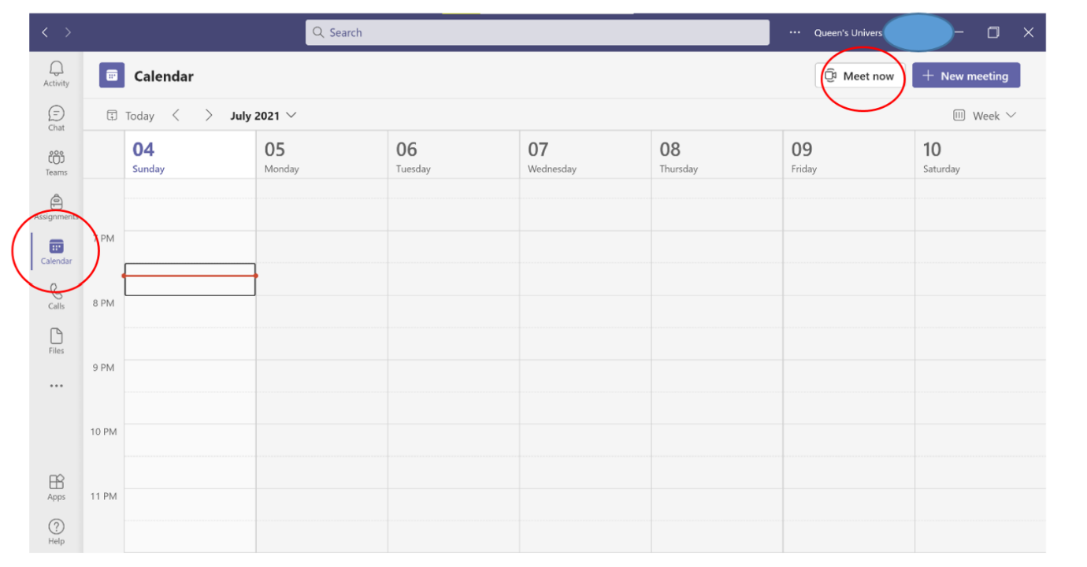

2. Start sharing your presentation using the Share content button. Alternatively, press Ctrl+Shift+E.

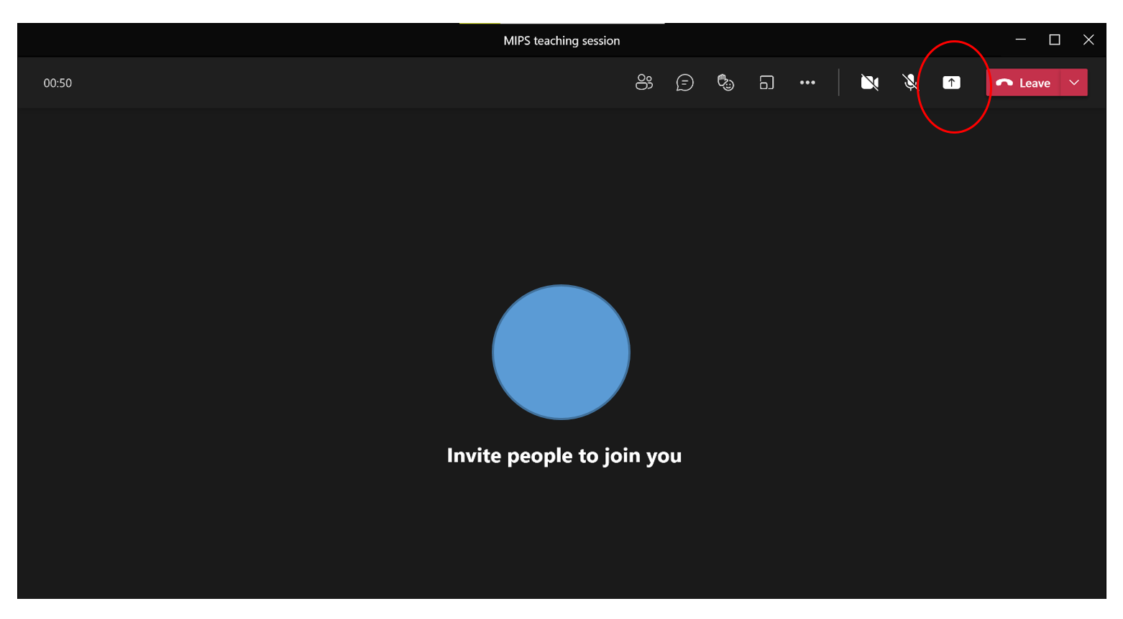

\*You can Share screen content such as your PowerPoint or the Screen on your computer

(eg. To show a website / quiz).

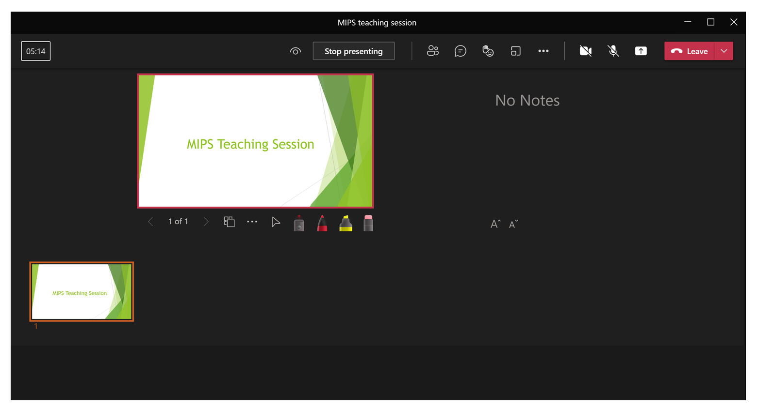

3. To start recording, click More actions / three dots icon and then Start recording. You can start teaching your lesson. You will receive a notification that you have started recording your meeting.

\*Make sure you’re not muted and you may turn on / off your camera as you wish.

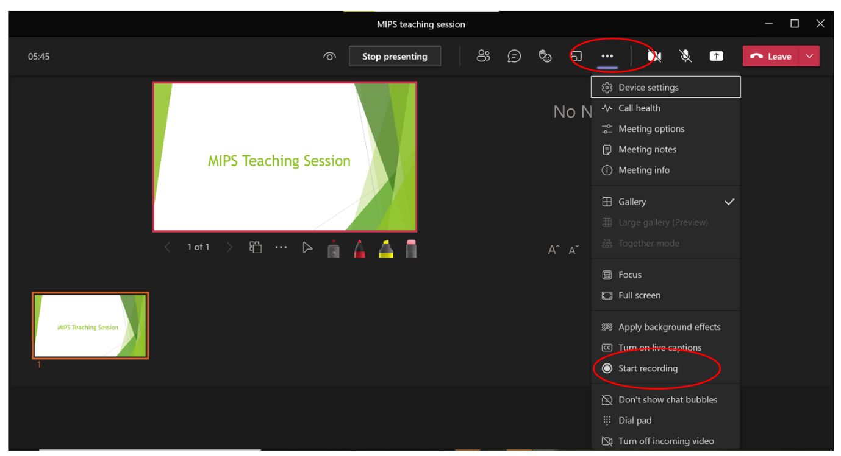

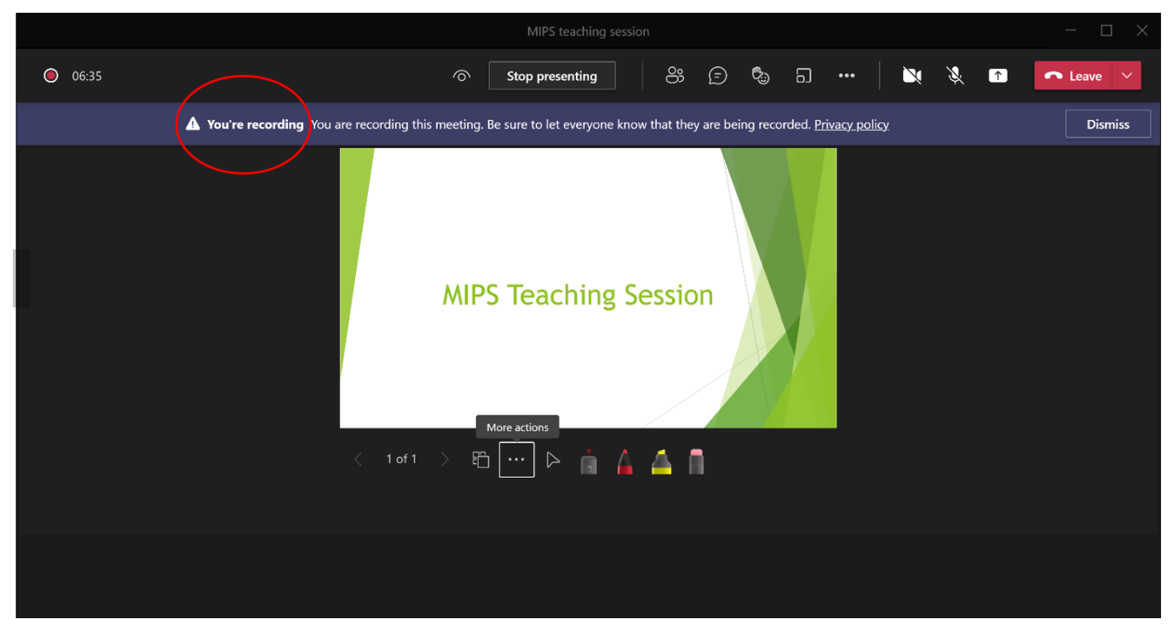

4. Once you have completed teaching your lesson, you can click More actions / three dots icon and then Stop recording.

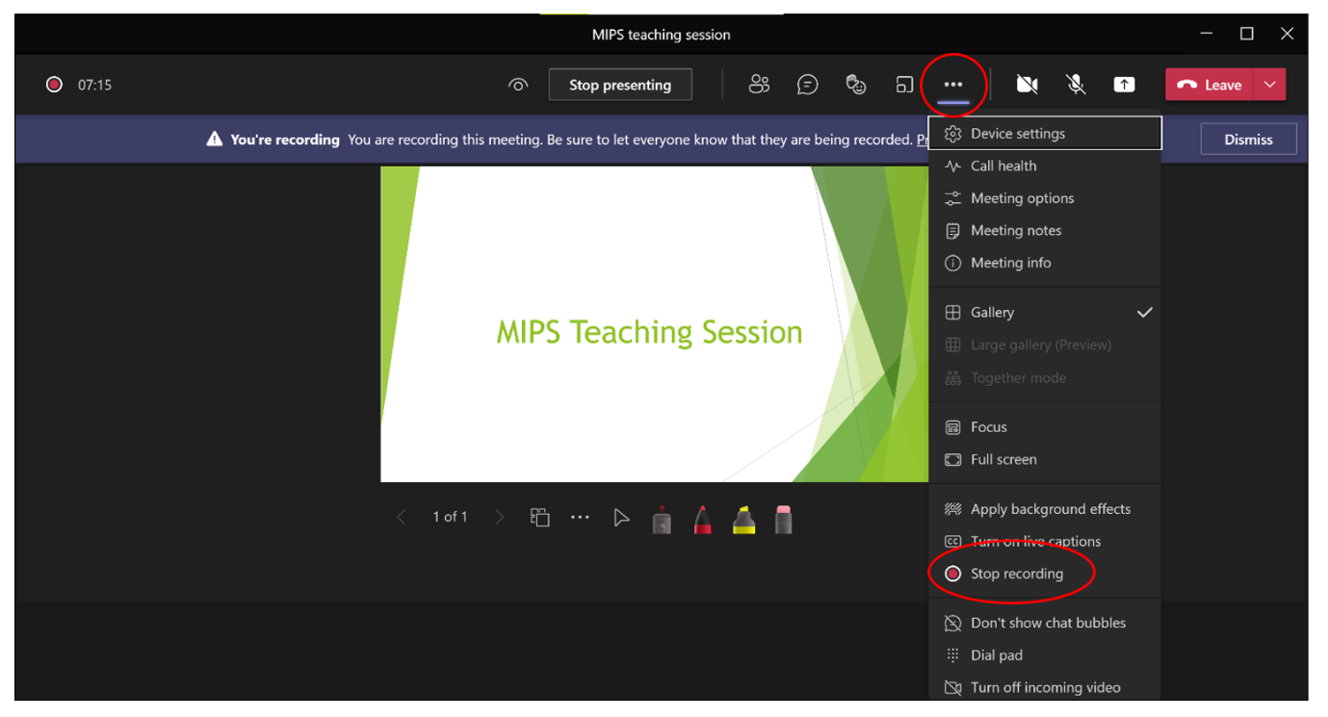

5. Depending on your meeting’s time duration, the recording may take from 30 minutes to 1 hour to form. You can find the recording on the meeting’s chat.

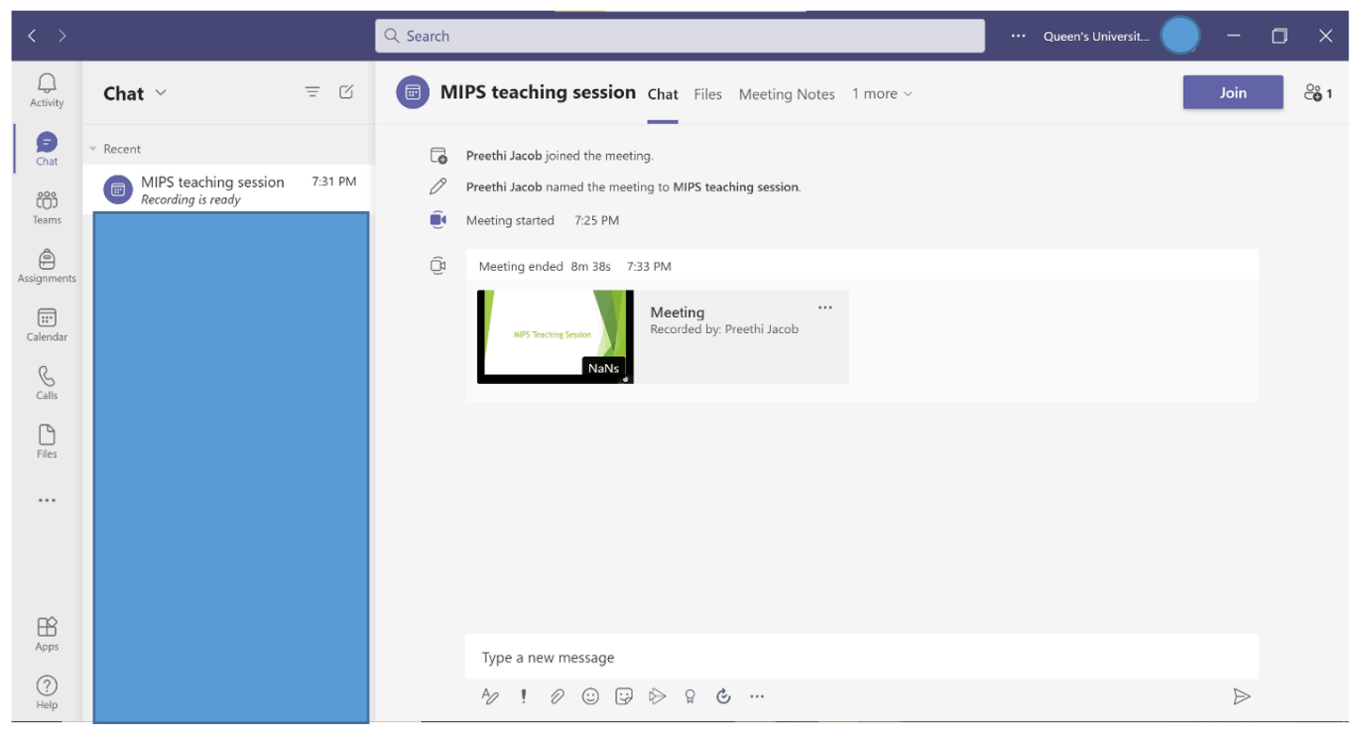

6. To download the webinar recording, you may click More actions / three dots icon on the video and then choose Open in Microsoft Stream.

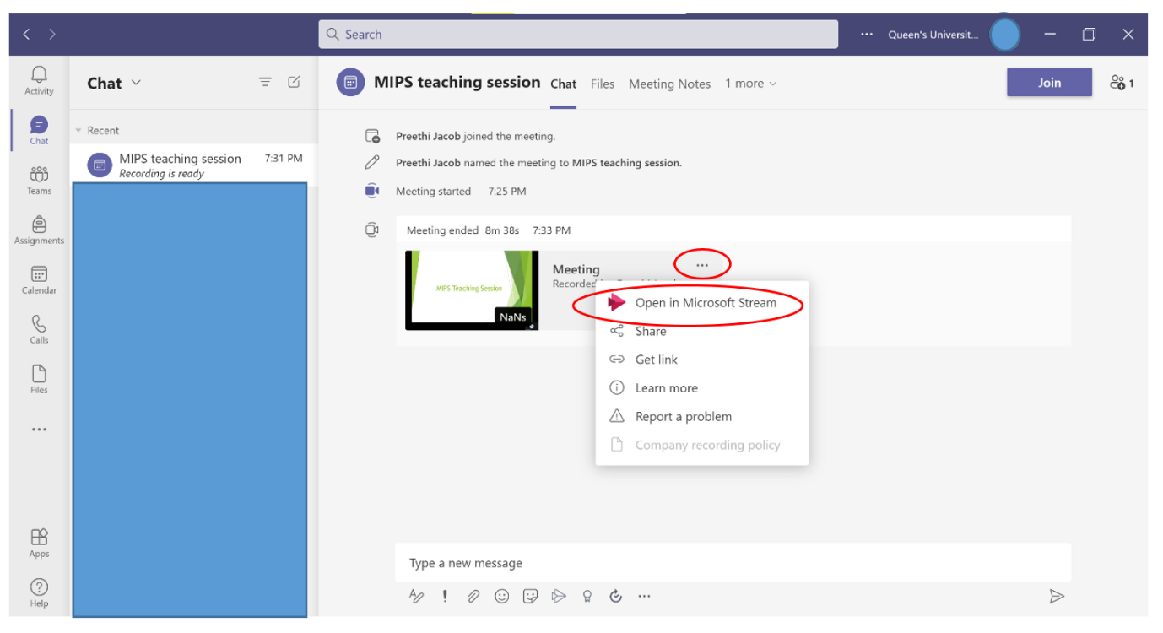

7. You will be redirected to the university’s login page. After logging in, the video recording tab on Microsoft Stream will automatically open.

8. Click More actions / three dots icon (below the video) and then Download video.

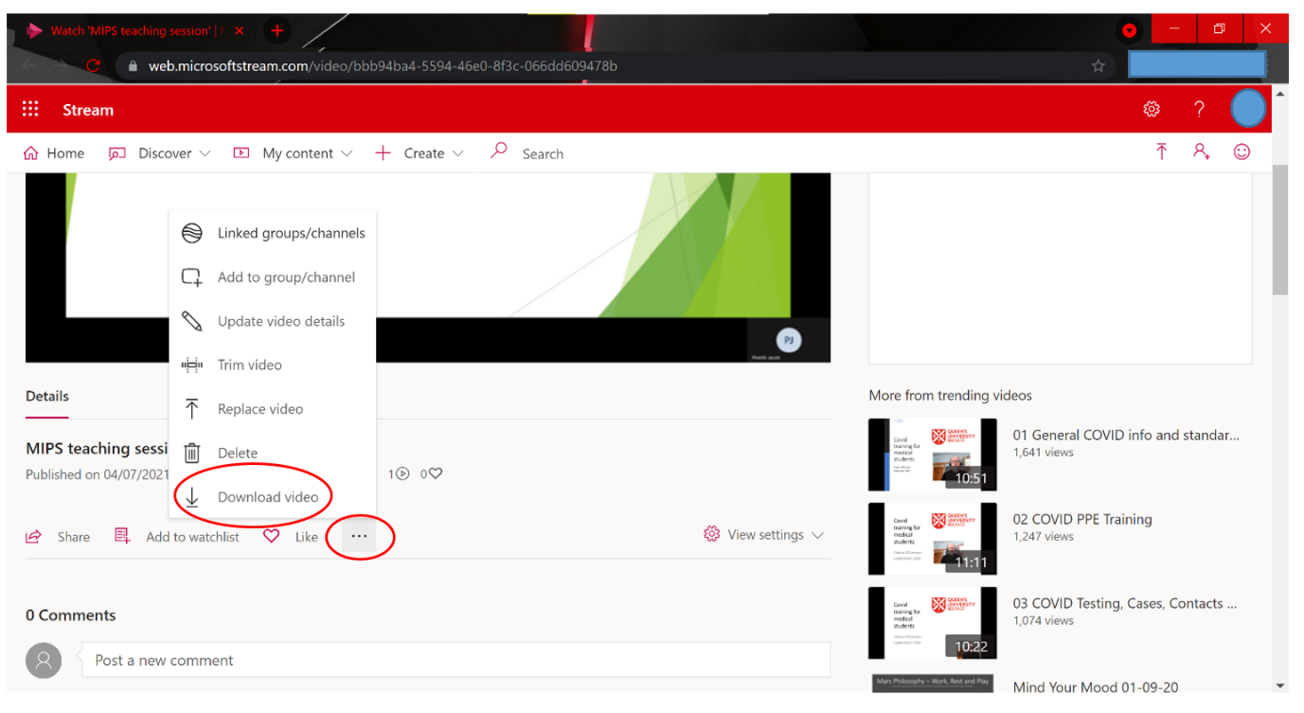

9. You can save the video in a folder and send it to your teacher. It can then be viewed in the classroom.

Alternatively, share the video as a file on an online platform such as the Classroom Microsoft Teams or Google Classroom (which all students have access to).

*(ii) Using Zoom*

*(New meeting, Share screen, Recording teaching session)*

1. Log into Zoom using a private account.

2. Click new meeting and share screen (to share presentation).

Make sure you’re not muted and you may turn on / off your camera as you wish.

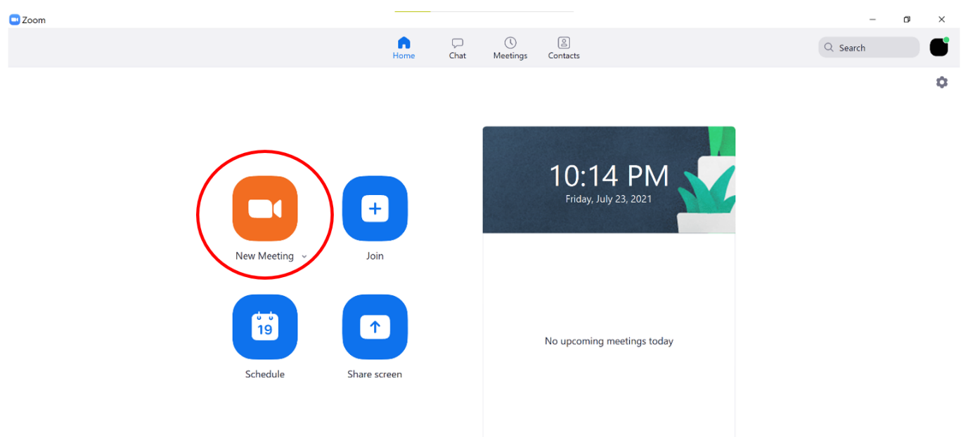

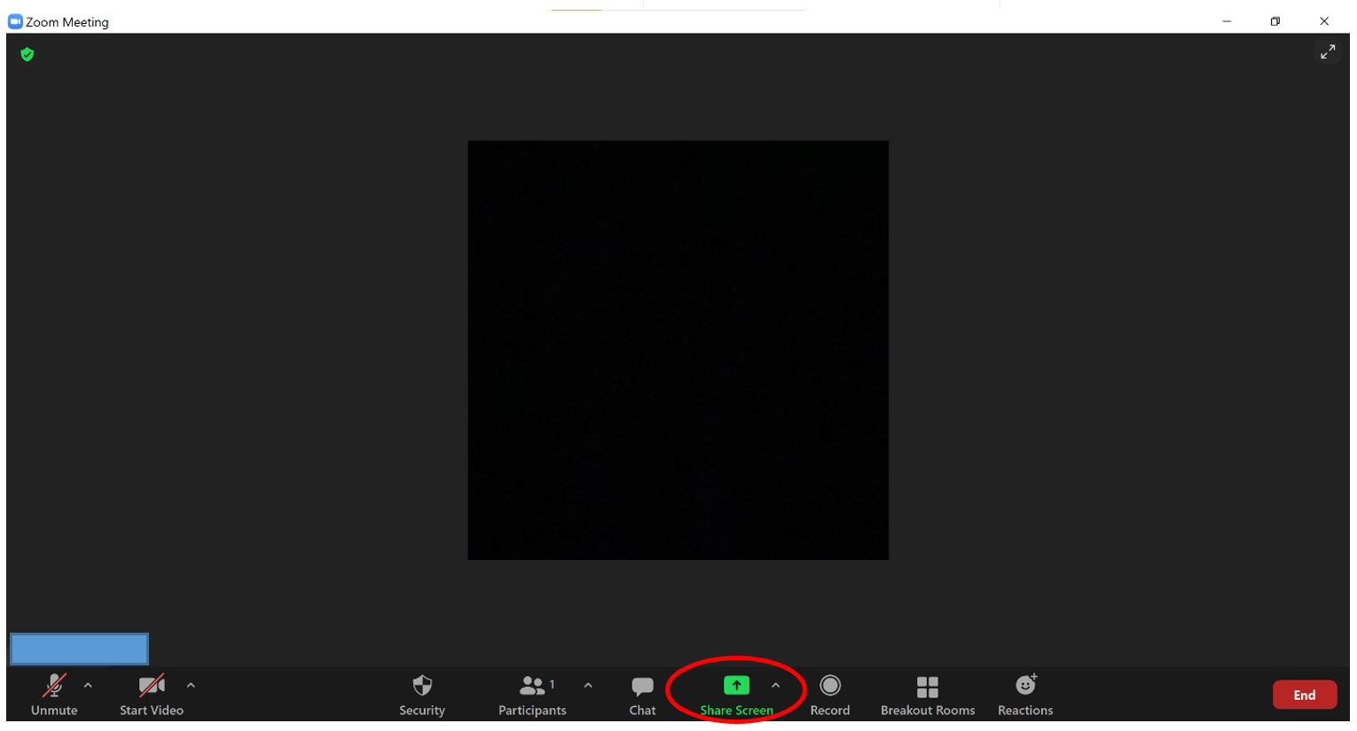

\*You can Share screen content such as your PowerPoint or the Screen on your computer (eg. To show a website / quiz).

3. To start recording your teaching session, Click Record (alternatively press Alt + R).

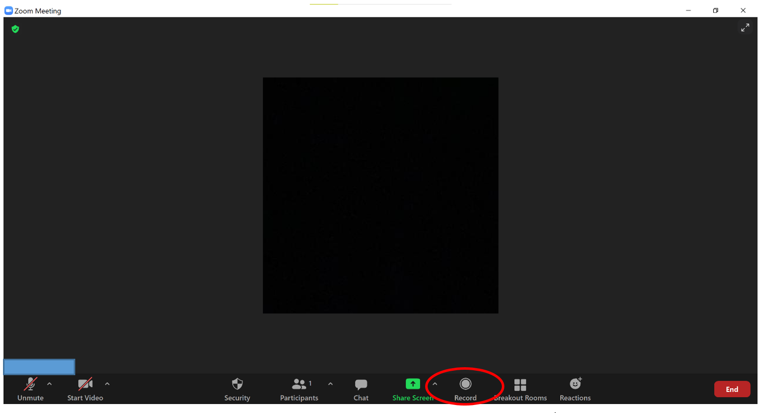

4. To stop recording, click Stop Recording (alternatively press Alt + R).

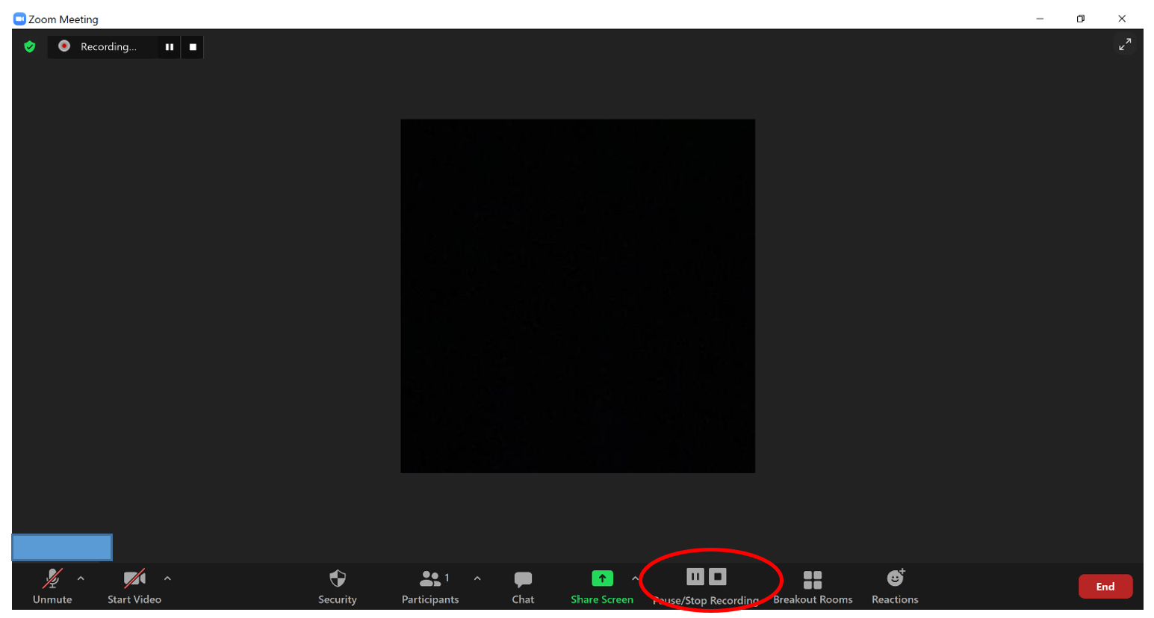

5. Once you end the meeting, you will be redirected to a folder where the recording file is stored.

6. You can then save the video in a folder and send it to your teacher. It can then be viewed in the classroom.

Alternatively, share the video as a file on an online platform such as the Classroom Microsoft Teams or Google Classroom (which all students have access to).

**4. How to encourage online discussion with pupils**

**1. Chat function on Online platform**

During the teaching session, pupils may use the online platform (Microsoft Teams, Zoom)’s chat / comment function to discuss the lesson.

**2. Mentimeter, Kahoot**

You may also use [Mentimeter’s Word Clouds](https://www.mentimeter.com/features/word-cloud)to aid classroom discussion.

Mentimeter can also be used to do live polls, quiz to make the class interactive. This website also can be used to prepare your teaching presentation which can be screen shared during the live/ recorded teaching session.

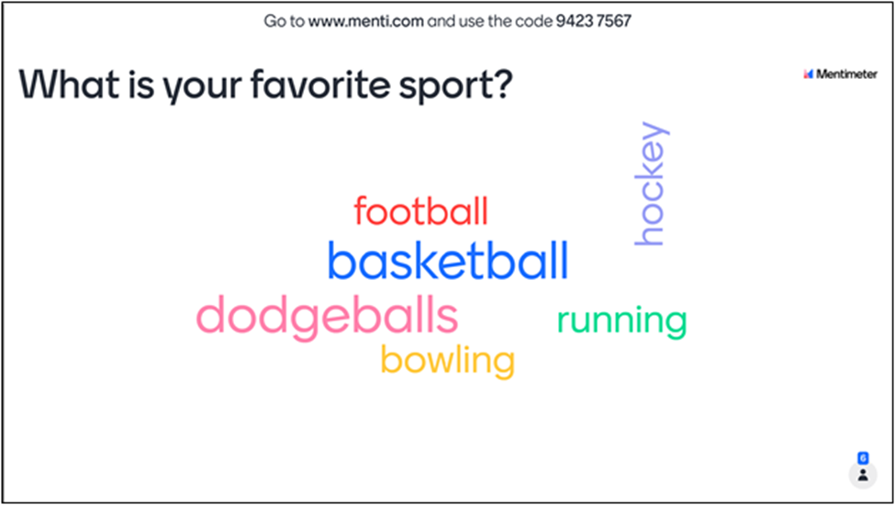

Mentimeter WordCloud (this would be appropriate if pupils have an individual device)

How to create Word Cloud on Mentimeter

1. Visit [www.mentimeter.com](http://www.mentimeter.com).

2. Create/ Log in to your private account.

3. Click +New Presentation

4. Click +Add new slide

5. On the toolbar, click Type and select WordCloud

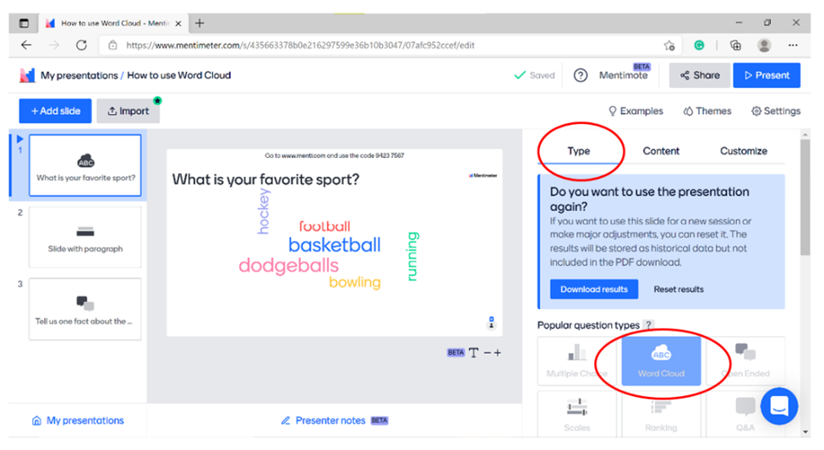

6. To add context to your WordCloud, add questions to aid discussion using the Content tab on the toolbar.

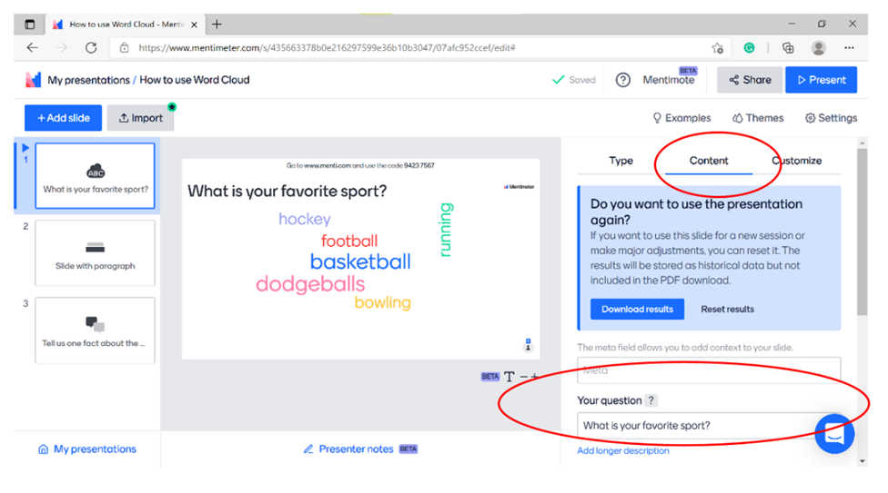

7. You can adjust the number of audience entry submissions using the Content tab, the Entries per participant button and Extras button.

Title: Entries per participant for Word Cloud  - Description: Click content, then entrie sper participant text box. 
Can select allow participant to submit multiple entries. 

8. To share WordCloud during the teaching session, present your presentation on internet explorer/ Google Chrome and share screen using the share screen function on the meeting platform (Zoom, Microsoft Teams, Google Hangouts).

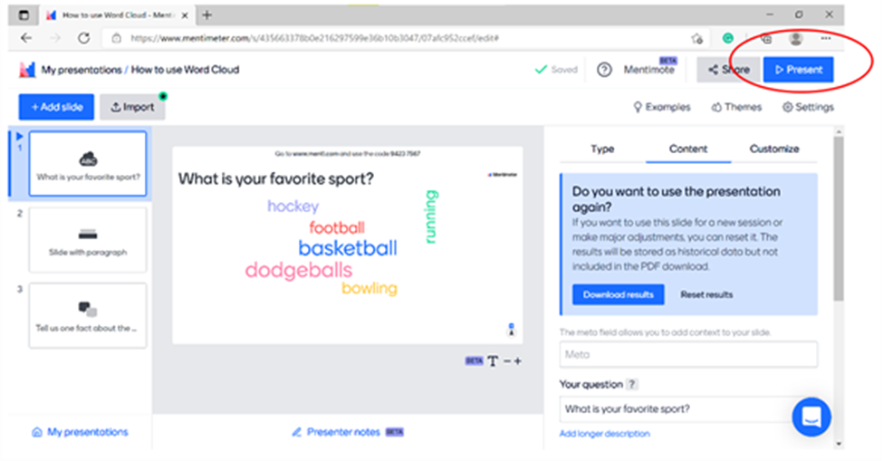

9. Ask pupils to visit [www.menti.com](http://www.menti.com) and type the presentation’s code into the text box.

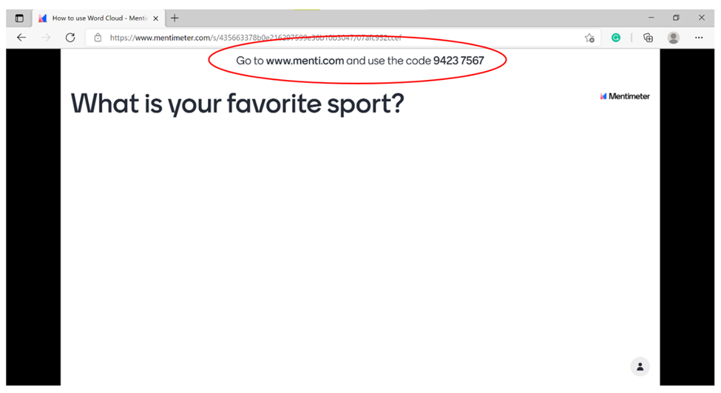

Alternatively, click share presentation and click and paste presentation link onto online classroom platform (google classroom or chat function of webinar platform). Pupils can then open the link and submit their entries.

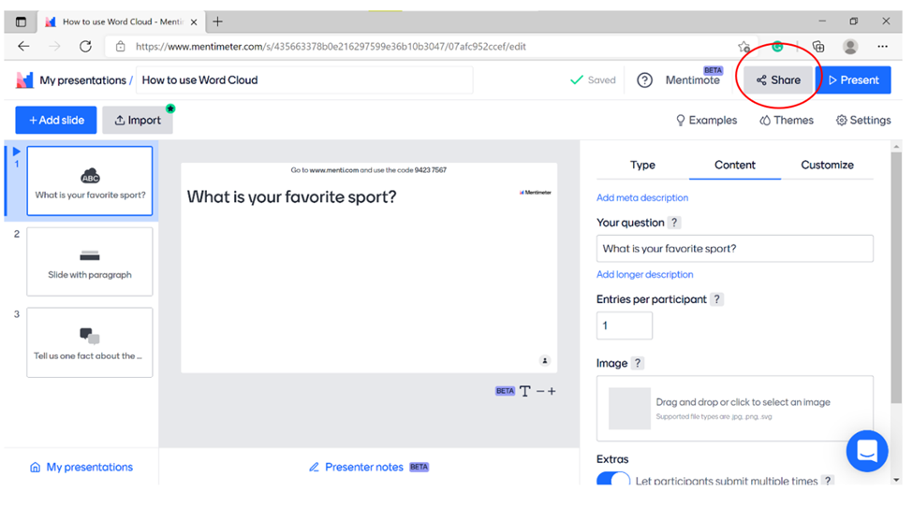

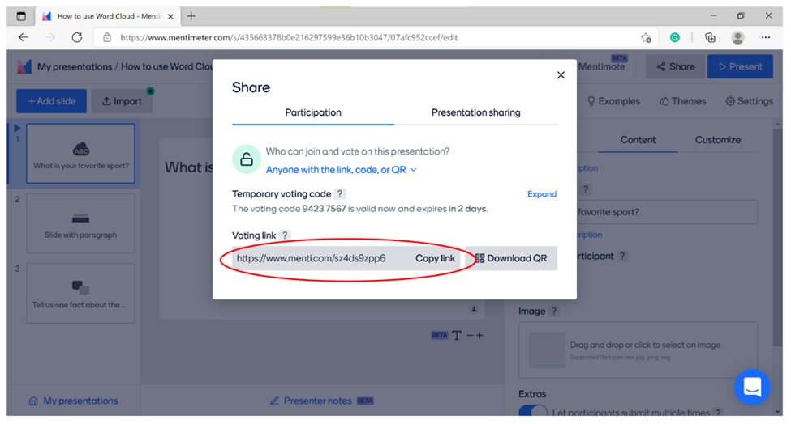

Other alternatives to Mentimeter, include [Kahoot](https://kahoot.com/). Similar to Mentimeter, in Kahoot, you can log in using a private account and create your quiz (game). The game pin can then be shared with the pupils during the teaching session.

**3. Using Breakout Rooms on Microsoft Teams**

Some of the icons/ buttons will appear live and active when other participants are in the meeting.

1. Once you have started your meeting, click Breakout rooms.

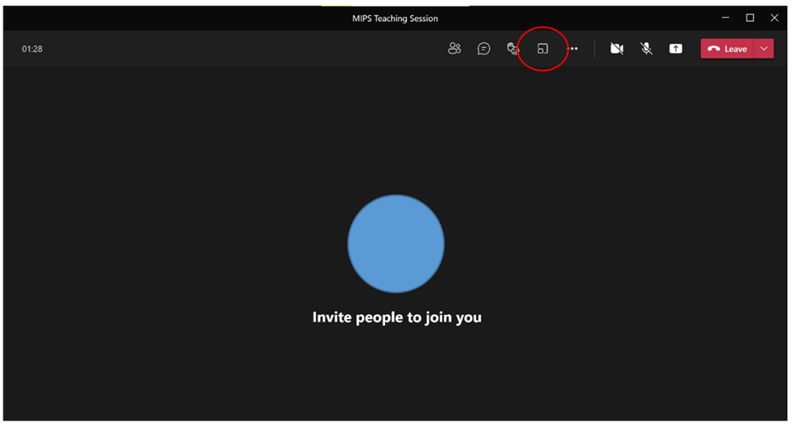

2. Once the popup box appears, select from the various options on how you would like to assign pupils to the breakout rooms. You can also select how many breakout rooms you would like to create. Following this, click Create rooms.

  You may click Assign manually if you would like to assign certain pupils to a breakout room. You may replicate groups that were already arranged in the classroom in the breakout room.

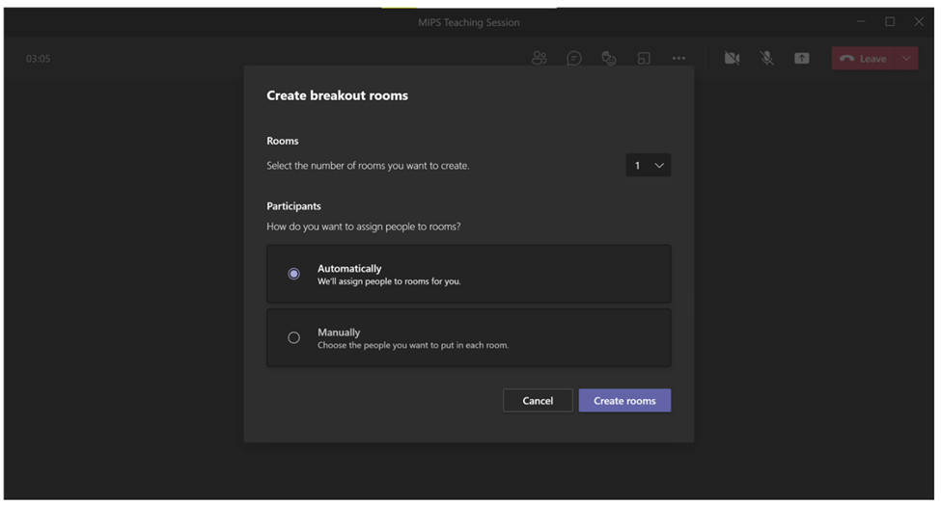

3. You will then be able to assign the meeting’s participants (pupils) to the respective breakout room. Once all pupils have been allocated to a breakout room, you can click Open All Rooms. This will allow the pupils to enter the breakout rooms and start the group activity.

Alternatively, click Assign participants to allocate pupils to breakout rooms.

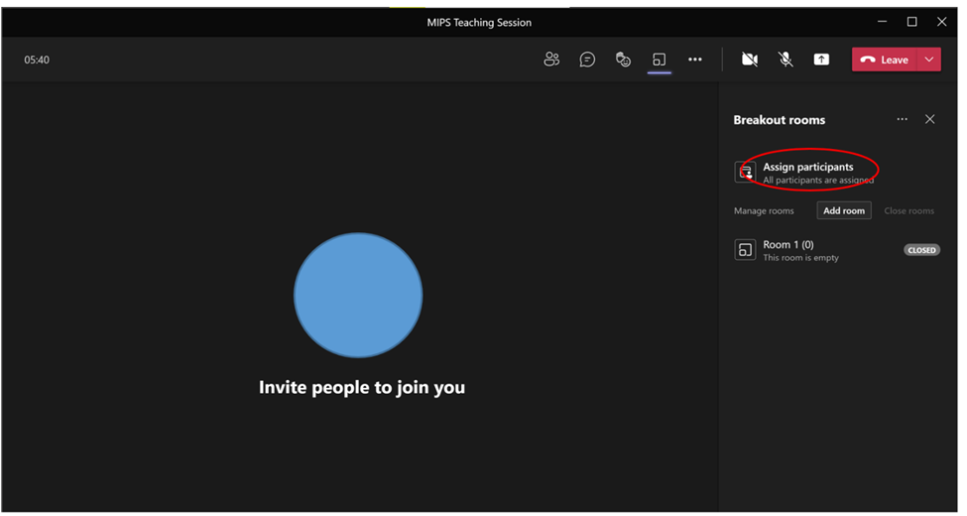

4. Click More Options of breakout rooms and then click Settings. This will allow you to assign special functions to the breakout rooms like time duration, automatically allow pupils to join breakout rooms, pupils can return to the main meeting at any time.

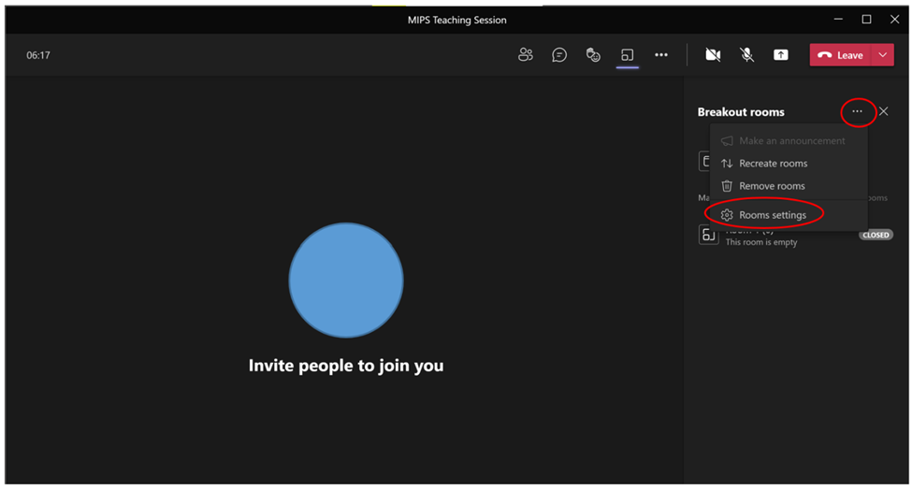

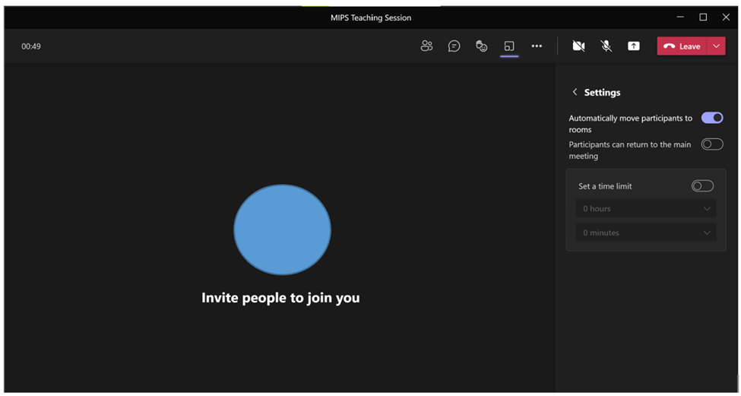

5. At the end of the group activity, click Close All Rooms to end the breakout room session. This will allow all pupils to return to the main meeting to attend the regular teaching session.

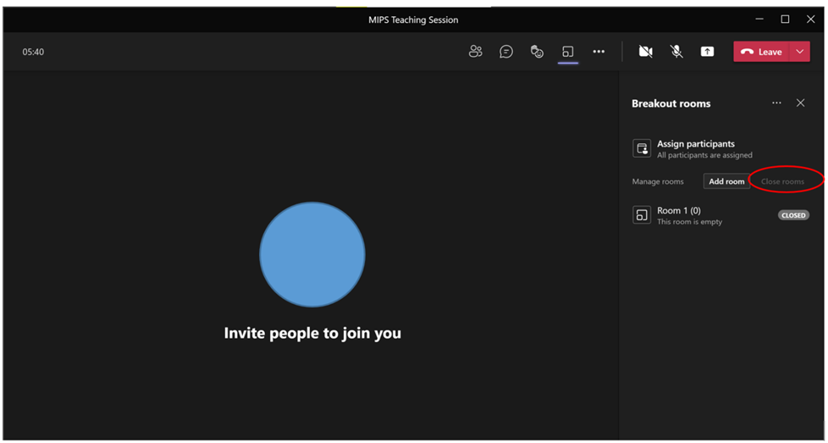

**4. Using Breakout Rooms on Zoom**

\*Some of the icons/ buttons will appear live and active when other participants are in the meeting.

1. Once you have started your meeting, click Breakout rooms.

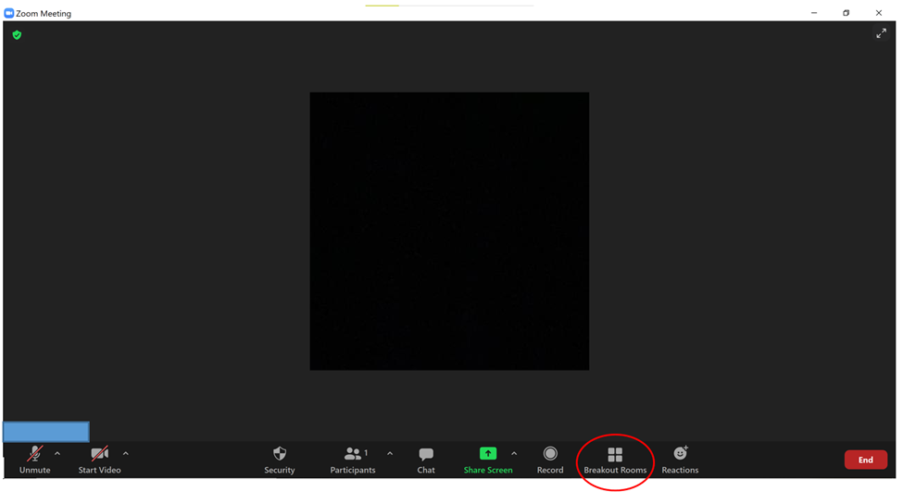

2. Once the popup box appears, select from the various options on how you would like to assign pupils to the breakout rooms. You can also select how many breakout rooms you would like to create. Following this, click Create.

You can click Assign manually if you would like to assign certain pupils to a breakout room. You may replicate groups that were already arranged in the classroom in the breakout room.

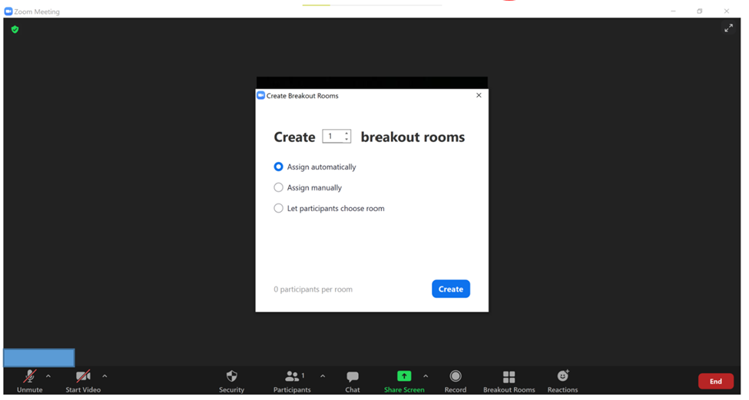

3. You will also be able to assign the meeting’s participants (pupils) to the respective breakout room by clicking Assign. Once all pupils have been allocated to a breakout room, click Open All Rooms. This will allow the pupils to enter the breakout rooms and start the group activity.

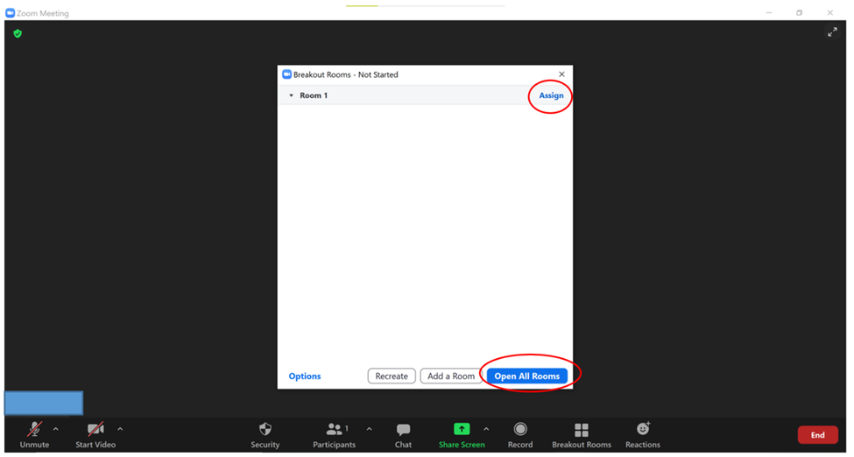

4. Once the breakout rooms have been opened, use the Broadcast Message to All button to send messages (or instructions) to all the breakout rooms (groups) simultaneously.

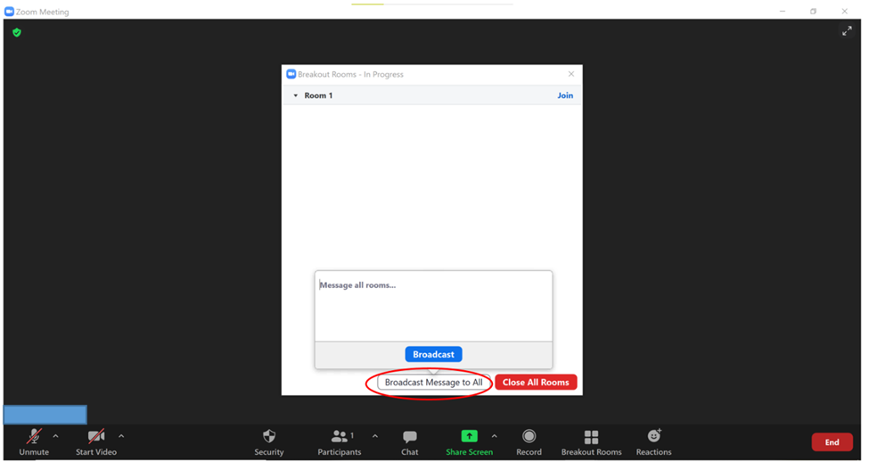

5. During the group activity, you will also be able to join certain breakout rooms if the group needs further instructions. This can be done by clicking Join on the respective breakout room name.

6. At the end of the group activity, click Close All Rooms to end the breakout room session. This will allow all pupils to return to the main meeting to attend the regular teaching session.

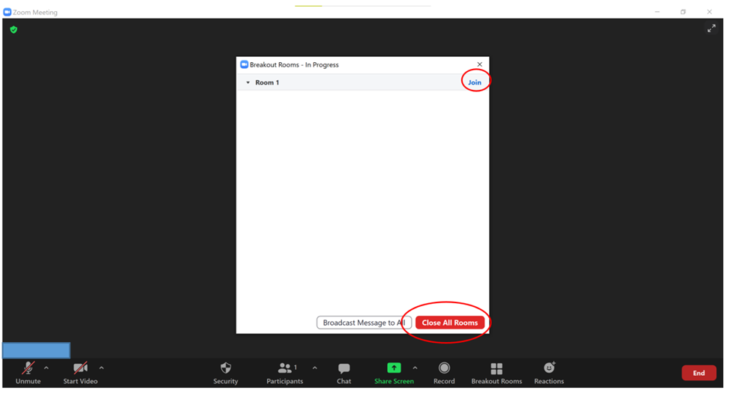

**5. Recorded teaching session:**

Pupils may use the online classroom platform (Google Classroom, Microsoft Teams)’s chat / comment function to discuss the lesson. You may then use the same function to answer doubts and discuss relevant points with the students.

**6. Practical Activities:**

Due to the Covid-19 pandemic, it is difficult to engage in face-to-face activities/ games with the class during the teaching session. We encourage you to utilize the online quizzes, games to make the teaching session as engaging and interactive as possible. We have outlined certain online worksheets, games and quizzes in the lesson units which you may use during your teaching session.

(1) Using Worksheets with online teaching:

You can access the worksheets on the websites provided in the respective lesson units. These may be used to aid teaching. If you find these very challenging for the pupils, we encourage you to edit these worksheets according to your lesson or the pupil’s capacity. You can also create your worksheets or search the internet for these.

(2) Using worksheets during Live online teaching:

You may email worksheets before your teaching session with the teacher. They can print these out and keep them ready for your class. These can then be discussed and completed during the teaching session.

(3) Using worksheets during Recorded teaching / as Homework

You may share the worksheet on the online classroom platform (to which students have access), which can then be completed online during the class or as homework.

(4) Using Quizzes with online teaching:

At the end of your teaching session, you may wish to use Microsoft PowerPoint to create a quiz to assess pupils learning. You can access quizzes on the websites provided in the respective units. This can be screen shared during the teaching session or similar questions can be used when creating your quiz.

Alternatively, you may use [Quizlet](https://quizlet.com/) to create flashcards which you can then screen share during your teaching session to engage the class in a quiz-style activity.

(5) Using Crosswords and Word Searches with online teaching:

Pupils enjoy completing word searches and crosswords during the teaching session. We encourage you to search the internet for these activity sheets on the internet for the respective lesson topics.

Alternatively, you may use [Crosswordlabs](https://crosswordlabs.com/) to create a personalised crossword for your teaching session. This allows you to cater the crossword to your class. You may also use this activity to teach the lesson by explaining the different hints/ answers as you go along.

You may also visit [The Teacher’s Corner](https://www.theteacherscorner.net/) to create personalized [word searches](https://worksheets.theteacherscorner.net/make-your-own/word-search/). This website also provides you with the tools to create [crosswords](https://worksheets.theteacherscorner.net/make-your-own/crossword/) and other [activity sheets](https://worksheets.theteacherscorner.net/).

Medics in Primary Schools

**Medics in Primary Schools**

**Healthy Body**

**Please discuss this guidance material with your class teacher before starting this unit, particularly in relation to practical activities, and act on her / his advice.**

Some parts of this material may have been covered already by your class as part of the Northern Ireland Key Stage 2 Curriculum. Your role may then be to reinforce pupils’ knowledge and understanding of these areas, rather than to teach them about their bodies as new material. This unit can contribute to *Personal Understanding and Health*, which is part of the Northern Ireland Curriculum’s area: *Personal Development and Mutual Understanding (PD&MU).*

For more information on PD&MU, and useful resources that can be downloaded, see [http://ccea.org.uk,](http://ccea.org.uk/)follow Curriculum and Assessment: Curriculum, then Areas of Learning, then Key Stage 1 & 2, then Personal Development & Mutual Understanding. Statutory requirements in this area are that teachers should enable pupils to develop knowledge, understanding and skills in:

*- their self esteem, self confidence and how they develop as individuals*

*- their management of a range of feelings and emotions and the feelings and emotions of others*

*- effective learning strategies*

*- how to sustain their health, growth and wellbeing and coping safely and efficiently with their environment.*

CCEA material can also be used as appropriate to develop pupils’ cross-curricular capabilities in *Communication*, *Using Mathematics*, and *Using ICT*(Information and Communication Technologies).

There are eight sections in this unit covering:

(1 – 5) *body systems*, confined here to the muscular, skeletal and digestive systems. Other systems are covered in *Healthy Brain*, *Healthy Heart and Lungs*, and *Healthy Skin.*You will find the ABPI website [www.abpischools.org.uk](http://www.abpischools.org.uk) particularly useful in relation to all body systems. This site enables access to a downloadable library of resources.

(6 – 8) *using food effectively and safely*, looking at the relationship between a healthy diet and the development of pupils’ bodies.

Although the material is broken down into weeks, please regard this as advisory as your actual programme should be decided through discussion between you and your class teacher.  Don’t feel under pressure to complete everything in this Guide: you will probably find that there is more material than you can use in the time available. Please note that some activities (marked \*) require advance planning or discussion with your class teacher the previous week.

Some elements may be omitted if they have already been effectively covered, or if they are regarded as too advanced for a particular class, for example: scatter graphs relating energy to the fat content of food, or photosynthesis as the inverse of respiration.

You may consider the pupil’s learning outcomes and question prompts for the lesson’s topic for each week as a guide to prepare your presentation.

**Week 1**

**1. What is a system?**

*Pupils should learn*

*- how to identify the components of a system*

*- how components of a system relate to one another*

*- what happens if components of a system are damaged or missing*

Introduce the idea of a system in general, as a group of interacting elements operating together as an effective unit. For example, pupils may already be familiar with a bicycle, computer or motor car, the water system in their home, or the solar system. These are made up of component parts that enable them to work effectively together as a single system, and which may not work effectively, or at all, if one of its components is damaged or missing.

Ask for other general examples.  Pick one example (possibly a bicycle), and ask pupils to explain how the components of the system work together. Ask what can happen if one component (for example: the bicycle chain or tyres) is damaged or missing.  Emphasise the idea that all components or organs in a system (including the systems in our own bodies) should function effectively for the system as a whole to be effective.  Compare how a system such as a Ferrari and the body functions due to its different parts working together effectively.

\*You may wish to display in your presentation slide a real system, for example a bicycle / Ferrari to aid discussion.

**2. What are our body systems?**

*Pupils should learn*

*- to identify major body systems, and show these on an outline of the human body,*

*- to identify some things that can go wrong with our bodies*

**Question prompt:**

*1. Can you name some body systems? (Possible responses include digestive, respiratory, circulatory, central nervous system, muscular, skeletal, reproductive, urinary, skin (though pupils may not use these words).*

*2. Can you tell where the liver (or another organ) is?*

\*Check in advance the school’s policy on sex education, as pupils are likely to suggest the reproductive system.

**Article:** View the links below for more information to guide preparation of your presentation.

- [www.wartgames.com/themes/humanbody/bodyparts.html](http://www.wartgames.com/themes/humanbody/bodyparts.html )

- [Our Body - Free Teaching Resources of Grade 3 Students | Learn Science Online (kidsworldfun.com)](https://www.kidsworldfun.com/learn-science/our-body.php)

**Activity – Where’s my liver?**

*Use this activity if students are delivering teaching the session online and pupils are in different locations with individual devices.*

Pupils may be divided into groups using online breakout rooms (see pages 00). \*Provide pupils with copies of Activity Sheet B2: *Body systems*, and ask them to locate each system on an outline of the body. Activity sheets can be accessed on the MIPS area of the Sentinus website: [www.sentinus.co.uk,](http://www.sentinus.co.uk/)under the title *Activity Sheets*. Pupils can discuss the activity sheet within their group and complete it. Pupils are asked to write the letter related to each organ in its correct location on the body outline. One pupil within each breakout room may then share their screen to the classroom to discuss their work. Alternatively, pupils may send a screenshot of their work to the online platform.

**Interactive activity: Group discussion – The Different Body Systems**

**Online (pupils with individual device):**

Pupils may be divided into groups using online breakout rooms. Ask pupils to view <https://scratch.mit.edu/projects/552403790/> within the breakout room. Each group is given one system of the body to discuss. They may discuss amongst their group and present 2-3 points on what they learnt to the class. Pupils may refer to the scratch link / internet for information on the body system.

**Question prompt:**

*1. What causes harm to the body?*

*2. What can you do to prevent harm to the body?*

**Activity: What can go wrong?**

***\**Check with your class teacher in advance if pupils may be sensitive to this activity.**

You may find that, as a starter, pupils may be motivated by the questions: *What can go wrong with parts of my body? What can I do about it?*You may wish to use Activity Sheet *B10: Damaged organs*here*.*

**Question prompts:**

*1. What happens when I go to the doctor?*

*2. What happens if I go to hospital?*

These questions may arise at other times during your school interaction. Please respond as appropriate.

**Interactive Activity: *Act it out***  **Online (pupils with individual device):**

1 Pupils may be divided into two groups or more.

2. Pupils may act out a given word (examples below) to their own group. You may send the action as a private message to this pupil. During this time, pupils within their group may keep their cameras turned on and microphone unmuted. While pupils of the other group may keep their cameras turned off and microphone muted. During this time, you may also pin the video of the pupil acting out the word so that only his / her video will be displayed during that time.

3. The time until the answer is guessed by the pupil’s group is recorded using a timer.

4. In each round, each group will go once. The time for the pupil to guess the answer is recorded. If pupils are not able to guess the action, you may provide hints.

5. The group which recorded the lowest time gains a point.

6. Finally, the group which gains the maximum points wins.

*Act it out*  (examples)

Stomach pain, headache, fracture, fever, doctor, blurred vision / eyesight, nosebleed, toothache, loose tooth, sore throat, breathlessness, heart ache, scrape/cuts.

Medicine, bandage, sleep, healthy food, fruits and vegetables, water, exercise, glasses.

**Interactive activity: Group discussion**  **Online (pupils with individual device):**

Pupils may be divided into groups using breakout rooms. Amongst the groups, pupils may discuss times when they visited the doctor for different treatment like prescription for medicine, stitches or to have discussion for their worries. This is to establish knowledge of how the public visits the doctor for different treatments. Afterwards, pupils may view the link [Knight Nurse | Games | Health for Kids](https://www.healthforkids.co.uk/game/knight-nurse/) and play the game on their own device.

**Activity: Body Glossary**

You will be introducing several technical terms in this and other sections of *Healthy Body. \**You may use Activity Sheet B7 or B8: *Body Glossary*here to enable pupils to build up a glossary of terms. Some words are included in this sheet, but pupils may add their own words, with their explanations. In Activity Sheet B7 pupils are asked to match terms with definitions: in B8 they are asked to make up their own definitions. Expect pupils to be able to identify body systems and organs, but not necessarily to remember all the names.

*You may wish to adapt this glossary activity sheet for other units.*

**Extension topic: What kind of cells is the human body made of?**

You might tell pupils that our body systems and organs are composed of cells and show them some of the wide range of human body cells. \*Search ‘human body cells’ on the Internet for appropriate images. The idea of cells, as the smallest units of life, is referred to later in sections on X-rays, and on the digestive system and nutrition. It’s useful for pupils to know (without detail) that our bodies are composed of different types of cells, with different functions. You may be asked about stem cells.

The following are examples of **question prompts** that could aid explanation of how the human body is made of cells which continuously multiply:

\*1. Display a photo of a baby and ask:

- Who is this?

- How did I get to adult / children size from this?

\* 2. Display an image of a LEGO construction:

- If I want to make a bigger LEGO model, what is required? (More LEGO bricks)

 3. Talk about growing living things requiring more ‘bricks’ but we call them cells. Talk about all living things being made up of cells – humans, trees, animals. Cells are very small and very few can be seen without magnification. A human body has 1013 cells. (Type as 10,000,000,000,000). A drop of blood has a similar number of cells as people living in the Republic of Ireland (about five million).

You may also draw the following structures on the interactive whiteboard or display the pictures on your presentation slide (online teaching):

1. Picture frame (representing the frame or skeleton of a person).

2. Calculator above the frame (representing the brain of a person).

3. Bicycle pump mid-frame (representing the heart of a person).

4. Recorder near the top of the frame (representing the vocal cords of a person).

5. Glove at the side of the frame (representing someone’s hand).

Following this, you may ask “What is represented here?” (A body – skeleton, brain, heart, vocal cords, hand). You can further explain how each of these parts of the body are made up of cells, but all have different functions. There are different types of cells within the body with different shapes and functions, for example, long cells like nerve cells, muscle cell. Human skin is made up of different cells working together to protect your muscles, heart and so on from damage.

**Article:**

View these links to help preparation of “Introduction to cell” topic.

<https://www.sciencelearn.org.nz/resources/186-introduction-to-cells>

<https://www.sciencelearn.org.nz/resources/175-cells>

**Animation:** <https://learn.genetics.utah.edu/content/cells/scale/>   View this link to demonstrate a size comparison of different cells, microorganisms to a coffee bean. Pupils can appreciate how small a single cell is within the body.

**3. What is our muscular system for?**

*Pupils should learn:*

*- about the structure and function of muscles*

*- to recognise how muscles can deteriorate or be damaged*

*- about the importance of regular exercise of the muscles*

Talk about sport and games. Ask pupils about injuries to footballers, netball and tennis players and other athletes, for example hamstring injuries. Encourage pupils to ask you questions about their muscles, and potential injuries: formulating questions is a key element of learning. Discuss the importance of warming up properly before exercise. Emphasise that muscles are less likely to be injured if they are made stronger and more flexible through regular use. Possibly discuss the dangers of athletes taking steroids or other drugs to improve their muscles.

Some ideas to cover, preferably through questioning the pupils:

- The muscular system functions to enable movement. Muscles enable you to walk, smile, eat and digest your food.

- Muscle movements are either voluntary or involuntary. Voluntary movements are those we control. Ask for examples (kicking a ball etc). Involuntary movements are those we do not control. Ask for examples (heartbeat, contraction of the muscles in the gut during digestion, etc).

- Muscles account for about 40% of our body mass.

- Muscle cells are tiny fibres that slide past each other to enable muscle tissue to contract (shorten) and relax (lengthen).

You may demonstrate this principle using a rubber band. You may stretch the rubber band to show comparison to how the muscle cells stretch. Muscles can contract to produce a pulling force: muscles can’t push. This means they work in pairs to produce opposite effects at, for example, your elbow or knee. As one muscle of the pair is contracted and shortened, the other muscle relaxes and lengthens. Together this pair of muscles is called an antagonistic pair.

**Demonstration: Muscle control**

You may demonstrate the following movements on yourself and ask pupils to follow your movements and feel the respective muscles. This demonstration can be performed in both face-to-face and online settings.

 1. Ask pupils to stand with their right arm bent at their elbow. Ask them to hold their upper arm muscles with their left hand while they straighten and bend their right arm. Discuss what they feel. They should be able to describe how their upper arm muscles (biceps) tighten.

 2. Ask pupils to find the antagonistic pair of muscles, the biceps and triceps, near their elbow joint. Ask them to copy the table below in their notebooks, and complete it to report the muscle movements when they bend their elbows, so that their biceps and triceps muscles contract and relax.

If this activity is done in a classroom, you may suggest a pupil place their hands over another pupil’s arm muscles in turn to feel what happens as they move their arms. This may further help them understand how the muscles tightens.  **Note: teacher supervision is required while doing this.**

**Animation / short video:**

View these links to aid explanation of how the biceps and triceps muscle work together to bend and straighten our elbow.

<https://commons.wikimedia.org/wiki/File:Animation_triceps_biceps.gif>

**Article:**[https://www.edumedia-sciences.com/en/media/231-biceps-and-triceps](https://www.edumedia-sciences.com/en/media/231-biceps-and-triceps" \t "_blank) - View this link to show the location of the biceps and triceps muscle in the arm. You can also draw on the space beside the image and explain each muscle’s movement when the elbow is bent and straightened.

|  |  |  |
| --- | --- | --- |
| **Movement (lower arm: raised or lowered?)** | **Biceps muscle (contracts or relaxes?)** | **Triceps muscle (contracts or relaxes?)** |
| **Lower arm is raised** |  |  |
| **Lower arm is lowered** |  |  |

 Ask what happens if muscles are not used regularly: they degenerate (atrophy) so inactive people cannot generate enough muscle activity to take part in intense extended exercise. Inactive people may become lazy and overweight / obese.  The increasing number of inactive children may lead to a rise in childhood obesity.  \*Be sensitive here if there are obese children in the class: check with your class teacher. Ask pupils to make a list of ways they could use to motivate an inactive child to become active.

**Worksheet:** You may use Activity Sheet B1: *Matching muscles*here.

**Online Quiz activity: Muscular system**

<https://kidshealth.org/en/kids/msquiz.html> - View this link to aid preparation of a quiz on the body’s muscles. The quiz can be shown to the pupils at the end of the teaching session to assess pupils’ understanding of the lesson. Alternatively, the link (quiz) can be screen shared or viewed on the interactive whiteboard and a classroom discussion can be encouraged to answer the questions.

*This type of activity can also be done with other lesson topics.*

**Week 2**

**4. What is our skeletal system for?**

*Pupils should learn:*

*- about the structure and function of the skeletal system*

*- to investigate bone structure*

*- to recognise dangers to the bones*

*- about the historical use of bone dimensions for measurement*

Ask pupils to feel some of their bones through their skin. Identify some of these. You might use the Latin names, but don’t expect the pupils to remember these. Ask them what makes up their skeleton. Explain that the skeletal system includes bones, ligaments and tendons. Ligaments and tendons are soft tissues made of collagen, a type of protein. Ligaments connect bone to bone, tendons connect muscles to bone. Emphasise that these are living, growing tissues, which can be easily damaged.

**Question Prompt:**

*1. Ask pupils what they know about bones.*

*2. How many are there in the human body? What do they do in their bodies.*

Ask them to first (i) list some of these bone functions on their own, then (ii) bring their lists together in pairs or small groups, and finally (iii) with the whole class to complete a list (for example: protection (skull and spinal cord, rib cage), giving shape, enabling movement, helping to produce blood, storing minerals, and transferring sound (in the ear).

*You may find this type of activity – asking each individual for a response, then asking for responses to be discussed in pairs or small groups, and finally in the whole class – useful in other units.*

**Article:** <http://kidshealth.org/kid/htbw/bones.html>(Nemours) View this link to aid explanation of the skeletal system.

*You can find useful resources for other areas of MIPS on the kidshealth site.*

**Interactive Activity: Reconnect them bones**

\*You will need sheets of A3 paper, and paper fasteners for this activity

**Face-to-face:** This instruction if students are delivering the teaching session online / face-to-face with all pupils in one classroom. Ask pupils to draw their skeleton on a sheet of A3 paper. Then ask them to draw the main bones separately to the same scale, and cut these out. Provide paper fasteners and ask them to connect these bones to form a skeleton. This activity may be done in groups / pairs.

**Interactive Activity: Mr. Bones Puzzle**

Poor Mr. Bones has lost some of his bones and he needs the pupils help to get his bones back in the right place. Number the missing bones from the handout (link below), and then take a look at Mr. Bones’ skeleton to figure out where each missing piece belongs. Then label the numbered bones back in place. Mr. Bones thanks you for your help! Pupils may also be asked to label the different bones and joints on the handout.

\*Handout: Mr. Bones Puzzle - <https://kidshealth.org/classroom/prekto2/body/parts/bones_handout1.pdf>

**Interactive activity: Label the Skeletal System**

<https://scratch.mit.edu/projects/552422194/> - View this link on the interactive white board to engage the class in a drag-and-label activity on the skeletal system. Open by pressing any white button. Otherwise, pupils may divide into groups to discuss and note down answers on a paper. You may then discuss the answers with the students.

If a limited number of electronic devices are available, pupils may be divided into groups and given a device for each group. Pupils are then asked to view the link and discuss within their groups to label the structure of the heart. You may then discuss the answers with the students.

**Alternative Online (pupils with individual device):**

<https://scratch.mit.edu/projects/552422194/>   View this link using share screen to engage the class in a drag-and-label activity on the skeletal system. Open by pressing any white button. Otherwise, pupils may divide into groups using breakout rooms to discuss and note down answers. You may then discuss the answers with the students.

Ask pupils how our bones can be damaged, and how damage can be avoided. For example: the use of car seat belts, cycle helmets etc for protection in traffic accidents. Emphasise the importance of using a helmet when cycling, as the skull protects our brain inside, which can be easily damaged.  Remind pupils about the importance of calcium in their bone structure.

Joints are formed where two bones meet. Ask pupils about different types of joint in the body (for example: fixed, pivot, saddle, ball and socket, hinge). Explain that bones at a joint are held together and supported by connective tissues, mostly made from collagen.

**Interactive Activity: Group Discussion**  **Online (pupils with individual device):**

Pupils can be divided into groups and be given one joint of the body. They may discuss amongst the group using a breakout room how the joint is formed with the different bones and ligaments. Then, they may present 2-3 points on what they learnt to the class.

**X-rays**

Ask pupils if any of them has been X-rayed, and why. X-rays are used in medicine and dentistry to look inside your body to see if there is anything wrong. Broken bones, some cancer growths, and tooth decay can be detected by an X-ray of a person. Explain to the class (with the agreed help of any pupil who has been X-rayed recently) what happens when you are X-rayed.

Explain that too much use of X-rays can be dangerous. Although they can pass through your body, they have high energy, and can also cause harm by altering body cells they hit. Medical and dental X-rays are usually very low intensity, so there is little hazard. But X-ray technicians go behind a lead shield when giving X-rays because they use X-rays often. You may need to explain the difference between *energy*and *intensity*. You may be asked about the uses of high energy radiation in radiotherapy (see [www.nhs.uk/conditions/radiotherapy](http://www.nhs.uk/conditions/radiotherapy)).

You might also discuss other means of looking inside the body (EEG, fMRI etc) here. Search for these on the Internet to find more information on these techniques.

**Extension activity: Handy measurement**

Your skeleton has many bones of different lengths. Ask pupils about bones and joints as historical units of measurement (for example: cubit, fathom, foot, hand, inch, pace, span). Ask them to measure and record some of these for themselves, and compare with others in the class. \*You may give pupils Activity Sheet B3*: Handy measurement*at the end of a lesson, ask them to find out what each unit is, measure these for their own body at home, and then compare with the rest of the class next week.

**Word search: Skeletal system**

<https://kidshealth.org/en/kids/bfs-sswordsearch.html>   View this link, the PDF file can be printed and shared with the pupils during the teaching session. Pupils can be asked to work in groups or individually to complete the word search.   Alternatively, individual pupils can view the word search on their device and complete it individually or in groups using breakout rooms.

**Quiz: Skeletal system**

<https://kidshealth.org/en/kids/ssquiz.html>  - View this link to aid preparation of a quiz on the skeletal system. The quiz can be shown to the students at the end of the teaching session to assess pupils’ knowledge of the lesson. Alternatively, the link (quiz) can be screen shared or viewed on the interactive white board and a classroom discussion can be encouraged to answer the questions.

**Extension Activity: Ergonomics 1**

The COVID-19 Pandemic has caused major disruption in school leading to a new outlook on delivering education. There has been a rise in online learning a rise in online learning. With the increase in screen-time and sedentary activities, maintaining good posture is as important as ever. Ergonomics is important in all aspects from at-home learning/ classrooms to play arena; wherever human beings work or play or rest. <https://blog.beaconmutual.com/ergo-distance-learning> - View this link for information regarding creating an ergonomic workspace for students practicing distance learning at home.

**Extension Activity: Ergonomics 2**

Ask pupils to identify good posture and bad posture from a mixed bunch of images. Pupils may be asked to demonstrate proper lifting procedure of a ‘dummy load’.

**Week 3**

**5. What is our digestive system for?**

*Pupils should learn*

*- to identify and locate the major organs in the digestive system*

*- to understand the operation of the organs of the digestive system*

This leads into sections 6 – 8 on Nutrition. Ask pupils what they already know about their digestive system.

- What are its organs? Expect responses: *mouth, throat, stomach, small and large intestines, liver, kidneys, pancreas.*

- Where are these organs? Show them on an outline of the human body. You might reuse Activity Sheet B10: *Body systems glossary* here, looking specifically at the digestive system,

- What are these organs for? What do they do?

**Worksheet – Food in transit through our digestive system**

Activity Sheet *B4: Food in transit*lists a number of steps that happen as food moves through your digestive system. These are given letters, but are not in a logical order. Ask pupils to list them in their correct order, and to use the letters to show on the diagram where these steps take place.

[**Article:** https://www.sciencelearn.org.nz/resources/1849-food-s-journey-through-the-digestive-system](Article: https://www.sciencelearn.org.nz/resources/1849-food-s-journey-through-the-digestive-system)  View this link to aid explanation of the digestive system.

Some ideas to cover, preferably by questioning the pupils:

- the digestive system is about 6.5 metres (20 feet) in length, and food takes about two days to pass through it

- Nutrients must enter your body cells to take part in chemical reactions essential to life

- Cells are the smallest unit of life. They are tiny, so food needs to be broken into very small pieces to enter your cells. Starting with saliva, this process is digestion, the breakdown of large food pieces to smaller soluble pieces.

|  |
| --- |
| **Interactive activity: Stumbling through the digestive system**  \*1. Set up certain spaces throughout the classroom to attach steps as per the game. Divide the pupils into groups of 4 – 5.  2. One pupil in each group will start at the starting line and take turns to roll a dice or use an online dice (<https://www.online-stopwatch.com/chance-games/roll-a-dice/>).  3. After rolling, move that number of spaces. Follow the directions on the space where you land.  4. Once a pupil reaches certain spaces with parts of the digestive system such as the mouth, oesophagus, stomach, small intestine and large intestine, another student within the group will take their place. Pupils can only move past that space after answering a question relating to the digestive system / on what they learnt on that day.  5. The first group to travel all the way through the digestive system to the finish line is the winner!  \*View activity sheet: *Stumbling through the Digestive System* for spaces sheets to print and place in classroom. |

**Online (pupils with individual device):**

Divide the pupils into groups of 4-5 using breakout rooms. In each group, pupils may view the link: https://kidshealth.org/classroom/prekto2/body/systems/digestive\_handout2.pdf. Each pupil may roll their own dice at their location or use an online dice on the internet

(https://www.online-stopwatch.com/chance-games/roll-a-dice/). Pupils may note down their place (space) on the activity sheet. The pupil within each group to travel all the way through the digestive system to the finish line is the winner!

 You may find the following websites useful:

[www.abpischools.org.uk](http://www.abpischools.org.uk) (ABPI) Follow Age 11 – 14, then Balanced diet and Diet and digestion

[www.nidirect.gov.uk](http://www.nidirect.gov.uk)  follow Health and wellbeing, then Living well, Healthy lives, then Heathy eating and Food safety and hygiene

**6. How can we use food effectively?**

*Pupils should learn:*

*- about factors that contribute to good health including diet and hygiene*

*- how different types of food are used in the body*

*- what can go wrong in our bodies, related to food*

*- what is a ‘good diet’*

*- how to keep their teeth healthy*

*- about keeping the body hydrated*

This theme can be developed through your questioning of the pupils. Find out what they already know about nutrition. Ask pupils what food is for. Discuss the nutrients:

- carbohydrates (energy)

- fats (energy storage, heat insulation)

- protein (body development)

- vitamins: A, C, D etc (vision, teeth, bones)

- minerals: sodium, potassium, iron etc (blood cells, teeth)

- calcium (bones)

- fibre (preventing constipation)

- water (cell support, making blood)

**Worksheet:** To enable pupils to summarise their knowledge and understanding of how their bodies use each nutrient, you may use Activity Sheet B5: *What is food for?*here. You may find it useful to use a spray diagram here (see page 23)

**Interactive Activity: Create the Food Pyramid**  **Online (pupils with individual device):**

Pupils may be divided into groups using breakout rooms. Pupils are asked to view the link <https://scratch.mit.edu/projects/554384241/> Click on the green flag, then Start game and drag different food items to the appropriate tier on the food pyramid. You may then discuss the answers with the students.

What can go wrong? Ask pupils what happens if you eat food or drink inappropriately. (\*Check if your class teacher knows any pupil with a diet related disease. \*Develop this sensitively in relation to obese or underweight pupils: check with your class teacher.) Diet related conditions include:

- coronary heart disease / hypertension

- some cancers

- being overweight / obesity

- dental problems (see the activity *Healthy teeth*below)

- other diet issues: iron deficiency, coeliac disease, diabetes, anorexia, bulimia, food allergies and intolerances

- issues related to poor food hygiene (see section 8)

- alcohol abuse

In the light of this, ask what is a ‘good diet’ or a ‘balanced diet’. Ask what is ‘junk food’. Many foods can be either ‘junk’ or ‘healthy’ depending on how and when they are eaten.

**Extension activity: Who is the Gastroenterologist?**

Sometimes your digestive system doesn’t work like it should and you feel sick. \*Invite a gastroenterologist (a doctor who specializes in digestive problems) to provide a short presentation to your class. This can be a live online session or a recording. Ask him or her to talk about the parts of the digestive system and ways to keep your digestive system working well. After the talk, pupils can be asked to write a thank-you note to the doctor, including one new fact they learned about the digestive system.  You may also seek help from your supervisor during your GP placement. This type of activity can also be done with other lesson topics.

**Article – the Eatwell Guide**

The Eatwell Guide shows the different types of food we need to eat – and in what proportions – to have a well balanced and healthy diet. There is useful information on the NHS site: [www.nhs.uk/live-well/eat-well/food-guidelines-and-food-labels/the-eatwell-guide/](http://www.nhs.uk/live-well/eat-well/food-guidelines-and-food-labels/the-eatwell-guide/) , and downloadable resources on the British Nutrition Foundation website: [www.foodafactoflife.org.uk,](http://www.foodafactoflife.org.uk/)follow 8 – 11 Years / Healthy Eating. See Key Fact 2 for useful resources at the foot of the screen.

**Healthy teeth**

1. Ask pupils to feel along their teeth with their tongues. Why have their teeth different shapes? Help them to identify incisor, canine and molar teeth, and to discuss what each shape of teeth is for.

2. Ask each pupil to write down a question about teeth. You may prefer to provide this as a homework exercise, and follow up with the rest of 2 and 3 the following week. Then in groups of three or four let them discuss these questions. Visit each group to help them find answers. Discuss key questions with the class.

3. Ask each pupil to write a sentence on how they look after their teeth. Bring these sentences together first within small groups, then in the whole class to develop a list of *Rules for Healthy Teeth*. In discussion, emphasise the importance of brushing their teeth in the morning and last thing at night, as well as cleaning between their teeth. Ask how often they visit their dentist for check-ups.

Pupils may use Word Cloud to submit ideas for keeping the teeth clean and healthy.

**Interactive activity: Group discussion**

Divide pupils into groups to aid group discussion using breakout rooms. Ask students to identify five food items each that contain calcium and sugar. Then you may discuss these items in the class and develop a table. A follow-up discussion can be how foods rich in calcium is good for teeth and those rich in sugar damage teeth. Remind pupils about the importance of a healthy diet.

**Game:** [Shine Time | Games | Health for Kids](https://www.healthforkids.co.uk/game/shine-time/) - View game as a follow up to presentation on the interactive board to emphasize importance of brushing teeth. Pupils may come to the board and play the game. Alternatively, pupils play the game on their individual device.

*Note: There is useful material on the KidsHealth site* [*Nemours KidsHealth - the Web's most visited site about children's health*](https://kidshealth.org/)*. Follow For Educators or For Parents for your own information or, with your class teacher’s advice, pass on For Kids to pupils.*

**Online Quiz activity: Digestive system**

<https://kidshealth.org/en/kids/dsquiz.html> - View this link to aid preparation of a quiz on the digestive system. The quiz can be shown to the students at the end of the teaching session to access student’s knowledge of the lesson. Alternatively, the link (quiz) can be screen-shared or viewed on the interactive whiteboard and a classroom discussion can be encouraged to answer the questions.

*This type of activity can also be done with other lesson topics.*

**Week 4**

**Article:** [Eating Healthily | Staying Healthy | Health for Kids](https://www.healthforkids.co.uk/staying-healthy/eating-healthily/)

View link to aid explanation on healthy eating.

Ask the class to identify items that (i) should, and (ii) should not be in their lunch boxes. Suggest that when they eat foods containing sugar, this should be during a meal, not between meals.  If possible, they should clean their teeth after each meal.

**Interactive activity: Draw an ideal lunch box**  **Online (pupils with individual device):**

Divide pupils into groups to aid group discussion using breakout rooms. Ask pupils to draw a healthy lunch box. Pupils can discuss amongst their groups for ideas. They may also decorate the poster using crayons and paint. Students can then explain their drawing (lunch box) in the general meeting afterwards. Remind students to include foods that would create a balanced meal, one which would be healthy for the body!

You may find the following website useful:

[www.abpischools.org.uk](http://www.abpischools.org.uk )(ABPI). Follow 11 – 14, then Science and Balanced Diet.

*You can find useful resources for other areas of MIPS on the ABPI site (check 8 – 11 and 11 – 14).*

**7. How do we get energy from food?**

*Pupils should learn*

*- about food supply security*

*- about drought and water conservation*

*- how basic life processes like digestion and respiration relate in order to maintain healthy bodies*

*- why our bodies need energy from the world around us*

*- where this energy comes from*

**Ensuring Food Security**

Ask pupils how they think climate change will affect food supply. Climate change leads to extremes of weather, such as droughts and floods. Droughts lead to reduced crop yields. Plants breathe through their roots so when the roots are in too much water by flooding they can’t get the gases they need, and they are also liable to fungal diseases.

Food security means that everyone in the world should have access to sufficient safe and nutritious food to enable them to live active and healthy lives. Changing climate is having a significant, but uncertain impact on food security. Government and intergovernmental policies need to be developed on water allocations, land use, and food safety. Further information on food security is available on [www.ifpri.org/topic/food-security](http://www.ifpri.org/topic/food-security) (the International Food Policy Research Institute).

**Energy from food**

Ask pupils: What is energy? A simple but correct answer is: *Energy is something that can make things (including itself) move*. Ask where this energy comes from to run, for example, washing machines, toys, cars, aeroplanes and people.  Electricity (mains and batteries), petrol and other liquid fuels, wind etc.

Ask pupils why their bodies needs energy. Some possible answers:

- The heart uses energy to pump blood around the body

- The body needs energy to keep warm

- The muscles need more energy during active sports.

- The brain uses energy to think and learn. (Emphasise that our brains need a lot of energy)

Where does this energy come from? Food and drink.

How do we get energy from food? Energy is released by respiration, a chemical reaction:

**Respiration:**  fuel + oxygen -> carbon dioxide + water + energy

Explain that this is a general chemical reaction for releasing energy from all types of fuel. Where do the fuel and oxygen come from? The fuel in a car is petrol or diesel: the fuel in our bodies comes from food. The oxygen comes from the air (about 20% of air is oxygen).

\*Check with your teacher if pupils are familiar with photosynthesis. If so, show that this is the reverse reaction of what happens in plants, and that plant material like wood, fruit and seeds can be used as fuel. The energy in this case comes from the Sun.

**Photosynthesis:**  carbon dioxide + water + solar energy -> plant material + oxygen

**Extension activity – Energy for life**

Use Activity Sheet *B6: Energy for life*here. \*Ask the pupils the previous week to bring in examples of nutrition information from food wrappers. Explain that kilojoules (kJ) and kilocalories (kCal) are both units of energy, and that a kilocalorie is about 4 kilojoules.  Both units are normally given on food labels, as the amount of energy available per 100 grams of the food, but kilojoule is an internationally used unit of energy.

The amount of energy pupils need depends on their age, sex and lifestyle. Energy is recorded in kilojoules (kJ). At age 11 the energy needed per day is from about 8,000 kilojoules (roughly 1,900 kilocalories) for a fairly inactive girl to about 11,000 kilojoules (about 2,600 kilocalories) for a very active boy.

**Homework – How much energy do I need to live?**

\*Ask pupils in advance to record their energy (kilocalorie) intake from food and drink during each of the three days before this lesson. Explain that they can find this information on food packaging labels.

In the lesson, ask pupils to compare their own figures with their recommended intake, which they can find on the UBM Medica Australia calculator: [www.mydr.com.au/tools/child-energy-calculator.](http://www.mydr.com.au/tools/child-energy-calculator) \*This needs to be done sensitively: please ask your class teacher for advice in relation to overweight pupils. Emphasise that, while too many kilocalories of energy above the recommended minimum intake can be deposited as fat in their bodies, they need at least this amount for a healthy lifestyle.

**8. How can we use food safely?**

*Pupils should learn*

*- how food can become unsafe to eat*

*- what can be done to avoid different types of contamination* 

*- that heavier rainfall can result in greater water contamination*

*- that increased bacterial growth resulting from climate change increases the danger of digestive illness*

Using food safely can be developed through your questioning of the children. Find out what they already know about food safety.  Climate change results in increased water contamination and increased bacterial growth, leading to digestive illnesses.

**Question prompt:**

*What can go wrong with food?*

*(for example: contamination by toxic material, fungus, bacteria or pests (animals or insects), and deterioration)*

- raw meat

- cooked meat

- frozen food

- chilled food

- canned food (meat, fruit, vegetables etc)

- fruit juices (in glass and plastic bottles, waxed containers etc)

- milk

Refer to ‘use by’ and ‘best before’ dates, and the difference between them. See [www.food.gov.uk/science/microbiology/use-by-and-best-before-dates](https://www.food.gov.uk/science/microbiology/use-by-and-best-before-dates)for information on this.

Discuss contamination with pupils

- types of contamination (toxins, e coli, salmonella, dirt, etc)

- how it happens

- its effect on the food, and on the consumer

- how contamination can be prevented.

If appropriate, link this with the *Glo Germ*hand washing exercise in week 2 of *Healthy Skin.*You may choose to use the *Glo Gem*equipment here*.*

**Article:** [https://www.sciencelearn.org.nz/resources/176-microorganisms-friend-or-foe](https://www.sciencelearn.org.nz/resources/176-microorganisms-friend-or-foe" \t "_blank) - View this link to aid explanation of microorganisms.

**Article:** <https://www.sciencelearn.org.nz/resources/588-bacteria-good-bad-and-ugly> - View this link to aid explanation of the different good and bad bacteria in and *around us.*

*There are other useful ideas on the* [*www.sciencelearn.org.nz*](http://www.sciencelearn.org.nz) *website. It’s worth browsing.*

**Animation:** <https://learn.genetics.utah.edu/content/cells/scale/> - View this link to show a comparison of sizes of different microorganisms.

**Division of Bacteria**

Bacteria divide in two about every 20 minutes as long as they have adequate food, liquid and warmth. Increasing global temperatures result in greater bacterial growth. Explain to pupils that bacteria die if it’s too hot, and don’t divide if it’s too cold. Start with one bacterium. Ask pupils to write down how many there will be after 20 minutes, 40 minutes, 1 hour…. Go on as long as you like (after 10 hours there will be over 400 million). Emphasise the importance of cooking raw meat thoroughly to kill bacteria, for a sufficient time at the correct temperature, and the importance of freezing perishable food that will be used later.

Pupils may not be aware of the differences between bacteria and viruses. If your pupils have direct access to the Internet, they may use Activity Sheet B11: *Bacteria and viruses* to find out more. This may be set as a homework.

 \*If available, show pupils a needle probe thermometer used for checking cooked food temperature

\* Packaging: Ask pupils to say why specific types of packaging are used for particular foods. It’s useful to have examples available.

**Homework:**\*Pupils may be asked the previous week to bring in sample packaging materials for food preservation, for example: cans (be careful with sharp edges), waxed boxes, plastic bottles.

**Interactive Activity – Safe storage**

**Face-to-face:** This instruction if students are delivering teaching session online / face-to-face with all pupils in one classroom. \*Ask pupils in advance to bring in pictures of food from magazine advertisements, for example, packs of flour, tomato sauce, milk, baked beans, canned soup, frozen peas, cheese, butter, sausages, eggs, yogurt, pasta. \*Provide pupil groups with A3 pages labelled ‘cupboard’, ‘refrigerator’ and ‘freezer’, and ask them to place each picture in its proper storage. More than one answer may be acceptable for some items.

Emphasise “always read the label”.

Discuss the significance of ‘use by’ and ‘best before’ dates.

**Online (pupils with individual device):**  Ask pupils to view the link <https://scratch.mit.edu/projects/552428851/> and drag different food items to their appropriate storage area. You may then discuss the answers with the students.  Press the green flag to start.

**Interactive activity – Design a poster on Food safety**

**Online (pupils with individual device):** This instruction if students are delivering teaching session online with pupils in different locations with individual device. Ask pupils to design a poster they can put up in their kitchens to show people how to store and prepare food safely. This activity may also be performed within groups using breakout rooms (to share ideas on creativity).

You may find the following websites useful for information on food preservation:

[www.howstuffworks.com/food-preservation.htm](http://www.howstuffworks.com/food-preservation.htm )(Discovery Communications)

<http://en.wikipedia.org/wiki/Food_preservation>

**Extension topic: How the body fights infection**

We have learnt about the different cells within the body. One such cell is the immune cells, white blood cell, macrophages, T cells, B cells, etc. These cells become active in different scenarios such as allergies, asthma, fever, etc. You may ask the pupils for times when they had a fever, allergic reaction, etc.

**Article:** <https://www.sciencelearn.org.nz/resources/165-fighting-infection-introduction> - View this link to aid explanation of how the body’s immune system fights infection.

**Developing cross-curricular skills in *Healthy Body***

**Communication:**

**-** using appropriately scientific words and phrases related to the units, for example: system, muscles, voluntary movement, biceps, digestive system, collagen, nutrition, respiration, contamination, and developing a glossary of these terms.

- reporting on investigations, using a range of media including paper, electronic, verbal class presentations

**Using mathematics:**

- drawing appropriate tables and graphs, and extracting useful information from these.

- food energy calculations

**Using ICT:**

- measuring temperature (if a sensor is available),

- word processing and presentation of information,

- accessing information on websites, and choosing appropriate material.

|  |  |
| --- | --- |
| **MED-Lab at W5**  If your school is planning a visit to W5, remind them that there is now a permanent exhibition covering aspects of the human body (supported by Almac, see <https://w5online.co.uk/explore/med-lab>) at W5. MED-Lab takes visitors through the systems that keep our bodies alive and working effectively. It displays advanced imaging technologies that enable us to see inside our body. It shows what can go wrong with our body and how we find out about and, ideally, fix the problem. |  |

**Notes**

**Medics in Primary Schools**

**Healthy Heart and Lungs**

**Please discuss this guidance material with your class teacher before starting this unit, particularly in relation to practical activities, and act on her / his advice.**

Apart from the section on blood (week 4), some of this material may already have been covered by your class. Your role may be to reinforce the children’s knowledge and understanding of the structure, function and protection of heart and lungs rather than teach these as new material (weeks 1 and 2). They are unlikely to have covered the function of blood in detail.

**Week 1**

**1. What is our heart, and what does it do?**

**2. How can we keep our heart healthy?**

*Pupils should learn:*

*- the location of the heart and lungs within the body, and their relationship with each other and with other organs*

*- that the heart is a muscular pump that pumps blood around the body*

*- the positive effects of diet and exercise on the heart*

*- the negative effects of nicotine, tar and carbon monoxide in cigarette smoke on the heart and lungs*

*- what is meant by blood pressure and pulse rate*

*- about Frank Pantridge’s part in the invention of the portable defibrillator*

*- how circulation of the blood was discovered by William Harvey*

The aims above can be developed through your questioning of the pupils. Find out what they already know about the heart. Ask them:

- where their heart is in their body

- what their heart does

Explain what is meant by blood pressure, and why this is important

Help pupils to locate their heart and lungs as their heart beats and they breathe in and out. Ask them to feel their pulse as blood flows through their arteries.

Develop an outline diagram of the heart from children's answers to questions, your own knowledge, and information from the Internet. Identify components of the heart’s structure. What is each component for?

You may explain about how the heart pumps blood through the body every time it beats. The right side of the heart is responsible for receiving blood from the body (through veins) and sending it to the lungs to get oxygen. The left side of the heart is responsible for sending blood from the lungs to the rest of the body through arteries. The heart, veins and arteries work together to send blood throughout your body (blood circulation).

**Interactive activity: Demonstration - Blood flow through the heart**

Use this instruction if students are delivering teaching session online with all pupils in one classroom.

Divide pupils into groups of five. Each pupil will have a role: VEIN, HEART, LUNGS, ARTERY, and BODY. You will require an object to pass between the group members (small ball / beanbag). Pretend the beanbag / ball is the blood.

The VEIN will send blood to the HEART.

The HEART will send blood to the LUNGS for oxygen.

The LUNGS will send blood back to the HEART.

Then the HEART will send the blood through the ARTERY.

The ARTERY will send the blood to the rest of the BODY.

The BODY will return the blood through the VEIN.

Practice tossing the beanbag in this circulation. When you think the pupils are ready, time the pupils for 1 minute using an online stopwatch (screen share). How many times can each group circulate the beanbag in the correct order in 1 minute?

This activity can also be done with one group to demonstrate to the class how the blood flows through the heart.

**Pulse rate**

The number of times your heart beats, that is it pushes the blood through your arteries (expand and contract with blood flow) in one minute is known as pulse rate. Ask pupils to predict what can change pulse rate. Ask students how they feel after running continuously for five minutes. Answers can include feeling breathless, hot, the heart beating against your chest.

**Interactive Activity – Pulse rate**

\*You need exercise space, an online clock / stopwatch and graph paper for this activity.

**\*Check with your teacher if any pupils may have heart or breathing problems**

**Online (pupils with individual device):** This instruction if students are delivering teaching session online with pupils in different locations with individual device. Demonstrate to students how to feel and measure their pulse. Have each pupil find his or her pulse by placing slight pressure on the wrist with the middle and ring fingers. You may display the online stopwatch using share screen to monitor exercise and pulse rate.

Ask pupils to measure their pulse rate:

(1)  before exercise (running on the spot / jumping jacks for one minute),

(2)  immediately after exercise,

(3)  five minutes later.

Ask pupils, if possible, to record the mean (average) of three pulse measurements at each point in the activity. Ask what they can learn from their results. You may use activity sheet H1: Pulse rate here.

Alternatively, pupils can feel their pulse at each point in the activity and compare how each pulse differs from the other. Pupils would notice that immediately after exercise the pulse will be strong and fast.

**Interactive activity: Label the heart** 

<https://www.sciencelearn.org.nz/labelling_interactives/1-label-the-heart>  View this link using share screen to engage the class in a drag-and-label activity on the structure of the heart. Alternatively, pupils may divide into groups using breakout rooms to discuss and note down answers.  You may then discuss the answers with the students.

**Extension Activity – Frank Pantridge**

Frank Pantridge was a heart consultant at the Royal Victoria Hospital and Queen’s University from 1950 to 1982. Ask pupils to use books and the Internet to find out about him, then to write 50 - 100 words about his achievements.  Ask them to find out what a defibrillator does, where they might find one, and why it is so useful.  View <https://www.youtube.com/watch?v=t9qSmO6Z0MI>  to learn about the amazing life of Frank Pantridge.

**Extension Activity – William Harvey**

Ask pupils to look at [www.bbc.co.uk/history/historic\_figures/harvey\_william.shtml](http://www.bbc.co.uk/history/historic_figures/harvey_william.shtml)and write about fifty words on him.

The Wikipedia site <http://en.wikipedia.org/wiki/William_Harvey>provides links to additional information.  <https://youtu.be/bIGB8aooakE?t=66> is useful to learn about how William Harvey discovered circulation within the body.

**Useful websites**

[www.abpischools.org.uk](http://www.abpischools.org.uk )(Association of the British Pharmaceutical Industry) - Follow 14-16 then Biology: heart and circulation. This is written for Key Stage 4, but edited material can be used at primary level

View this link to aid preparation of a quiz on the healthy heart. The quiz can be shown to the students at the end of the teaching session to access student’s knowledge of the lesson. Alternatively, the link (quiz) can be screen shared or viewed on the interactive white board and a classroom discussion can be encouraged to answer the questions. This type of activity can also be done with other lesson topics.

**Week 2**

**1. What are our lungs, and what do they do?**

**2. How can we keep our lungs healthy?**

*Pupils should learn:*

*- the location of the lungs within the body, and their relationship with other organs*

*- that we need oxygen to stay alive, and that this comes from the air*

*- how circulation and respiration relate in order to maintain healthy bodies*

*- that air enters the lungs by breathing*

*- the effects of coughing and sneezing in spreading disease*

*- about asthma*

*- the effect of exercise on the lung and diaphragm muscles*

*- that smoking can cause lung cancer, emphysema and chronic bronchitis*

The themes can be developed through your questioning of the pupils. Find out what they already know about the lungs. Ask them:

- where their lungs are in their body

- what their lungs do

- what is in the air they breathe in (mainly nitrogen, but emphasise oxygen) and breathe out (some carbon dioxide and water vapour)

- what happens when they cough or sneeze

**Interactive activity: Demonstrating how the diaphragm and lungs work together to help us breath**

**Online (pupils with individual device):**

You can demonstrate how these structures work together on yourself and then ask pupils to follow your movements.

1. Put one hand on your chest and the other on the upper part of your tummy.

2, Now breathe in deeply. You will notice that your chest and your tummy rise as the air goes into your lungs.

The above activity would explain how the lungs inflate (chest rises) and the diaphragm lowers itself (lungs can inflate to maximum potential and help create a vacuum in the lungs to pull air in) to allow breathing in. When you breath out the lung expels all the air out (chest falls) and the diaphragm returns to original position.

**Extension Activity – Breathing lungs**

\*You need exercise space and facilities, clocks or stopwatches, and means of measuring lung capacity

and volume, for this activity. \*Check with your teacher if any pupils may have heart or breathing problems. Ask pupils to measure:

1. their lung volume,

2. their breathing rate before and after exercise (running on the spot for one minute),

3. their peak flow rate

What can they learn from these results?

**Animation:**<https://www.youtube.com/watch?v=eGicIbMde2E> - View this link as a follow up to the above activity to show how the lungs and diaphragm work together to help in breathing.

**Article:**<https://kids.britannica.com/kids/article/lung/353400> - View this link to aid preparation of your presentation on Lungs.

Develop diagrams of the lungs from children's answers to questions, your own knowledge, and information from reference books or the Internet. Identify its structure. What is each component for? Explain the blood flow connection between the heart and lungs, and to the rest of the body.

**Article:** <https://www.stanfordchildrens.org/en/topic/default?id=anatomy-of-the-respiratory-system-in-children-90-P02950> - View this link to aid preparation of presentation on structure of the respiratory system

**Video:** <https://www.youtube.com/watch?v=0giiDDBJVQU> - View this link to learn about the structure of the respiratory system

**Interactive activity: Label the respiratory system**  **Online (pupils with individual device):**

View this link  <https://scratch.mit.edu/projects/556966292/>  using share screen to engage the class in a drag-and-label activity on the structure of the respiratory system. Alternatively, pupils may divide into groups using breakout rooms to discuss and note down answers. You may then discuss the answers with the students.

**Question prompt:**

*1. What causes damage to your lungs?*

*2. How does one take care of the lungs?*

Identify dangers to the lungs (from children’s answers to your questioning):

1. dust and dirt (including asbestos),

2. chemicals,

3. vape and cigarette smoke,

4. germs / bacteria

**Interactive activity: Create a Healthy Lungs Poster**  **Online (pupils with individual device):**

Use this instruction if students are delivering teaching session online with pupils in different locations with individual devices.

As a follow up to the above topic or teaching session, students can be asked to design a poster individually on how to keep lungs healthy or one of the following listed topics. Alternatively, students may be divided into groups using breakout rooms. Each group can then be asked to design a poster on different ways to keep the lungs healthy. Examples for poster theme include:

1. Smoking is bad for health

2. Exercise makes your lungs stronger

Alternatively, the above activity can also be given as a **homework activity** after the teaching session.

Ask the children what protection is needed against each of these, what protection do we already have, and how can we enhance this protection? \*Before discussing asthma, lung cancer or other lung conditions, check with your class teacher if this may be a sensitive issue for some pupils.

\*Check if your school is involved in *Smokebusters,*organised by Cancer Focus Northern Ireland (https://cancerfocusni.org/primary-programmes/smokebusters/). If not, suggest they join.

**\*Next week is devoted to Asthma. You should read the following notes in advance, and act accordingly.**

**\*Asthma**

Week 3 of this unit concentrates on asthma. It would be useful to ask pupils to spend about half an hour in advance browsing through [www.abpischools.org.uk/topics/](http://www.abpischools.org.uk/topics/) (Follow Breathing and asthma in the Topics column). This is written for Key Stage 3, but can be used at primary level. The *NHS* site [www.nhs.uk/conditions/asthma/](http://www.nhs.uk/conditions/asthma/) is also useful.

9

9

\*You should read Tier 3 (pages 14 – 16) of **The National Capabilities Framework for Professionals who care for Children and Young People with Asthma** at [National-Capabilities-Framework-3.pdf (e-lfh.org.uk)](https://www.e-lfh.org.uk/wp-content/uploads/2022/09/National-Capabilities-Framework-3.pdf).  This lists the asthma-related learning outcomes relevant to doctors in training.

\*Find out in advance from your class teacher which pupils in your class have asthma and whether it may be appropriate to ask them specific questions in class. Ask the teacher to read through the next week’s work and let you know by email if any parts may cause problems. Please suggest to pupils with asthma that they should bring their inhalers with them next week.

**Week 4 – Asthma**

***This week’s material is based on work produced in 2001 for the SCAMP programme by the South and East Belfast Health and Social Services Trust.***

*The material assumes that you have successfully* *covered*

*Unit Code MED 1028 (Cardiovascular, Respiratory and Haematological Systems) Case Number 6*

*Pupils should learn:*

*- how asthma affects the lungs and related breathing tubes / airways*

*- how asthma can be prevented*

*- how a mild attack of asthma can be treated in an emergency*

*- how an attack of asthma can be treated in an emergency*

*- how asthma can be treated in the long term to prevent future attacks*

*- what other people can do to help people with asthma*

**5. What is asthma?**

Again, the aims above can be developed through your questioning of the pupils. Ask them:

- what they already know about asthma

- if they know anyone with asthma

- if any of them has asthma

You can use questions like *What next*? Nationally, about 15% of key stage 2 children have been diagnosed with asthma, so you may get help from some children with asthma in your class. **Check with your class teacher first about whether encouraging pupils to discuss their asthma is appropriate**.

**What is asthma?**

Asthma is a condition that affects the air tubes (mainly the trachea and two bronchi) that carry air into and out of our lungs. The muscles around these tubes can tighten and they become narrow. They produce mucus which then tends towards blocking the already constricted tubes. The origins of Asthma as a condition are uncertain. If it begins before the age of twelve it is probably an interaction between genetic factors and early life exposures (for example, certain viral infections and allergen exposure).  If after age twelve the source is more likely to be a trigger of environmental origin. At present there is no cure for asthma, but there are several fairly successful means of treatment. Asthma is non-transmissible: it is not caused by germs.

**What are the triggers for asthma?**

If your class teacher considers it appropriate, start by asking pupils with asthma what causes their asthma attacks. Triggers for asthma are any things that irritate your breathing tubes and cause the symptoms of asthma. These are shown in the table below, which is ordered in relation to the frequency of the trigger. Some people’s asthma is associated with substances they work with, like paint sprays, animals, flour, latex and sawdust. Asthma differs from person to person and they may be affected by one or more different triggers.

|  |  |  |
| --- | --- | --- |
| **Infections, like colds and influenza** | **Allergies, like pollen and dust mites** | **Animal fur and feathers** |
| **Home: condensation, mould and damp** | **Exercise** | **Sudden changes in weather. Wind, humidity, thunderstorms** |
| **Feelings and emotions, like laughter** | **Heating in buildings** | **Being outside** |
| **Some food and drink** | **Smoking tobacco, vaping**  **(e-Cigarettes) and smoke from other sources** | **Some cuddly toys** |

**What are the symptoms of asthma?**

Asthma symptoms include:

- a feeling of tightness around your chest,

- finding it hard to breathe,

- wheezing when you breathe out,

- a lot of coughing.

As a means of remembering these symptoms you can ask pupils to remember the acronym: SWIFT

**S**  **S**hortness of breath

**W**  **W**heezing

**I**  **I**ncreased coughing

**F** **F**ast breathing

**T** **T**ightness in the chest

Some or all of these symptoms happen because the lining of the breathing airways of someone with asthma swells and produces mucus, and the muscles around your breathing airways begin to tighten.

More severe asthma attacks include:

- becoming very short of breath,

- working hard to breathe (indrawing of the rib cage, including above and below the chest wall), and

- being unable to speak in sentences.

**How do inhalers help?**

If any of these symptoms occur it will become harder to breathe and you should then use your **reliever** inhaler, which treats the symptoms. There are two main types of inhaler:

- **Reliever inhalers** are used when symptoms occur. They relax the muscles of your breathing airways to help air to get in and out of your lungs. They should relieve your symptoms within a few minutes, but may cause a temporary faster heartbeat. Reliever inhalers are usually blue.

- **Preventer inhalers** must be used regularly, normally twice a day to reduce symptoms, so they need to be taken every day even when you are well.  They reduce the inflammation inside your airways to enable air to get in and out of your lungs more freely. Preventer inhalers can be red, brown or orange. Black or purple inhalers are combinations of reliever and preventer.

**What action is needed in the event of a pupil having a mild asthma attack?**

If a child has a mild asthma attack, then:

- try to calm the child

- loosen any tight clothing

- seat the child in an upright position

- encourage deep, steady breathing

- use the reliever (one puff of the (usually blue) reliever every 30 seconds, up to ten puffs)

If the child improves within five minutes, then let her / him resume previous activity.

If the child does not improve, call her / his parents or guardians, and continue using the reliever every 30 seconds. See the guidelines below for a severe attack.

**What action is needed in the event of a pupil having a severe asthma attack?**

If a child is having a severe asthma attack, then

- have someone contact a doctor and the child’s parents or guardians immediately

- try to calm the child

- loosen any tight clothing

- seat the child in an upright position

- encourage deep, steady breathing

- use the reliever (one puff every 30 seconds)

If the child’s condition has not improved at this point, dial 999 for an ambulance.

- if the child has a supply of oral steroids, give these now.

- while awaiting the ambulance you can give the child a further round of up to 10 puffs blue salbutamol inhaler

**Week 5**

**3. What is your blood, and what does it do?**

*Pupils should learn some of the following:*

*- that blood carries essential gases and food to all parts of the body*

*- the difference between arteries, capillaries and veins*

*- the function of red cells (oxygen and glucose carrying), white cells (disease protection) and platelets (clotting)*

*- the role of blood in developing resistance to disease*

*- what anaemia is, and how it is related to diet*

*- what blood tests are for*

*- about the work of the Blood Transfusion Service*

The objectives above can be developed through your questioning of the children. Find out what they already know about blood. What is blood?  What are its components?  What does each component do?  How can blood be used to detect potential illnesses? What are blood tests for? The NHS Blood and Transplant website [www.blood.co.uk/about-blood/components](http://www.blood.co.uk/about-blood/components)is useful here. Blood is not part of the current Key Stage 2 curriculum, so their knowledge of blood is likely to be considerably less than they know about the heart and lungs.

**Worksheet:** You may use Activity Sheet *C2: Blood, glorious blood*here for consolidation and revision.

Ask the pupils to identify the differences between arteries, capillaries and veins. Explain what each does, and how its form enables each to perform its specific function.

**Properties of Blood**

Use the answers from the pupils, and your own knowledge and understanding, to build up a spray diagram, summarising the properties of blood. You can find information on developing spray diagrams on [www.open.edu/openlearn/science-maths-technology/engineering-technology/spray-diagrams](http://www.open.edu/openlearn/science-maths-technology/engineering-technology/spray-diagrams)

*You may find it effective to use spray diagrams in other units.*

**Worksheet**: You may use Activity Sheet *C3: Spraying blood*as a starting point. You might build up a class response on the interactive whiteboard.

The information on your spray diagram should be similar to the information pupils have written into their Activity Sheet *C2: Blood, glorious blood*. Ask pupils which sheet they think would be most useful in helping them remember information about blood. Some pupils prefer listing information in words and brief notes only, others find diagrams more useful. Explain that different people learn and remember in different ways.

**Animation:** https://www.getbodysmart.com/circulatory-system/general-composition-blood - View link to aid explanation of composition of blood. You will also find a useful animation demonstrating the components of blood in a step-by-step manner. There is useful information on other body systems on the general *Get Body Smart* website: [www.getbodysmart.com](http://www.getbodysmart.com)

**Online (pupils with individual device):**  You may also demonstrate the activity using your own materials during the online teaching session. \*The following materials should be sourced in advance. Use the three straws to signify blood vessels. One straw will remain free. The second straw will be completely closed by wrapping a rubber band around the middle of it. The third straw will be partially closed with the rubber band. Explain to the pupils that the straws are blood vessels in which two of them have become damaged due to cholesterol build-up in the body from eating junk food. The drinking fluid signifies the blood flowing through the blood vessels (straws). Ask pupils to take a sip of the “blood” using each straw, to demonstrate how blood flows more easily through healthy blood vessels.

You may refer to the websites below, and your own background, to develop pupils’ understanding of the need for blood donation, how donated blood is used, and the uses of blood tests.

- [www.nibts.org](http://www.nibts.org )(Northern Ireland Blood Transfusion Service)

- [www.blood.co.uk](http://www.blood.co.uk )(NHS Blood and Transplant)

- [www.nhs.uk/conditions/Blood-tests/Pages/Introduction.aspx](http://www.nhs.uk/conditions/Blood-tests/Pages/Introduction.aspx )(NHS) about blood tests

**Useful websites**

- [www.abpischools.org.uk](http://www.abpischools.org.uk )(Association of the British Pharmaceutical Industry) - Follow 11 – 14, then Science: breathing and asthma. This is written for Key Stage 3, but edited material can be used at primary level

- <https://cancerfocusni.org/cancer-prevention>

**Developing cross-curricular skills in *Healthy Heart and Lungs***

**Communication:**

**-** using scientific words and phrases related to the units, for example, heart, lungs, circulation, respiration**,**red cells, white cells

- making posters to illustrate, for example, the action of the heart, lungs and blood, the dangers of tobacco smoke

- reporting on investigations, using a range of media including paper, electronic, verbal class presentations

**Using mathematics:**

**-**accurate time measurement, volume measurement,

- drawing tables and appropriate types of graph

- calculating mean values of sets of results

**Using ICT:**

- word processing and presentation of information,

- accessing information on websites, and choosing appropriate material.

**Notes**

**Medics in Primary Schools**

**Healthy Skin**

**Please discuss this guidance material with your class teacher before starting this unit, particularly in relation to practical activities, and act on her / his advice.**

*Healthy Skin*is unlikely to have been covered in class. Work on the assumption that most of this material is new to pupils. This unit can contribute to *Personal Understanding and Health*, which is part of the Northern Ireland Curriculum’s area: *Personal Development and Mutual Understanding (PD&MU).*For more information on this aspect of the primary school curriculum, see [http://ccea.org.uk,](http://ccea.org.uk/)follow Curriculum, then (drop down) Key Stage 1&2, then Personal Development and Mutual Understanding. The material can also be used as appropriate to develop pupils’ cross-curricular capabilities in Communication, Using Mathematics, and Using ICT (Information and Communication Technologies).

You may consider the pupil’s learning outcomes and question prompts for the lesson’s topic for each week as a guide to prepare your presentation.

**Week 1**

**1. What is skin?**

**2. What does it do?**

*Pupils should learn:*

*- the structure of their skin, including its basic components*

*- the purpose of each component of their skin*

**Question prompt:**

*- Why is skin important?*

*- What does it do for us?*

*- What would happen if we didn’t have skin?*

**\*Check in advance if the school has these resources:**

- lenses (+20D, if available) or hand magnifier

- Sellotape (for skin peeling)

- "head" and other types of thermometer

- (if available) temperature sensors and computer, microscopes

**Online activities**

Activity instructions should be used if students are delivering teaching sessions online with pupils in different locations with individual devices.

**Interactive Activity – Investigating my skin**

The theme should be developed through your questioning of the children. Ask pupils to carefully look at their own skin (or a Sellotape peeling). The Sellotape peeling is made by sticking a piece of Sellotape to the pupil’s fingertip and removing it (an impression of the pupil’s finger print should be seen). Ask them to draw and describe what they see. You may find Activity Sheet *S1: Magnification*useful here to get across the idea of magnification.

**Interactive Activity – Skin temperature**

Discuss how the pupils feel when they are outside. Do they feel cold or hot? This can show how the outside temperature is different from the temperature of the body. Suppose it is the winter season, the temperature of the skin would be warmer. You may explain how the body would create warmth for itself as a means of protection using the fat within the body or you receive insulation from the clothes that you wear.

**Activity: Skin Structure**

Develop on the board a diagram of the skin (which should be similar to the diagram below) from pupils’ answers to questions. Also encourage the pupils to ask you questions. Do **not**show the diagram or this website as a first step. The diagram on the ABPI web resource: [www.abpischools.org.uk](http://www.abpischools.org.uk), follow all Topics, scroll to skin-structure-and-function and Next can be used at the end of the topic for consolidation or revision. Pupils need not remember the diagram, but they should understand the relationships between components. Please note that this material is written for the 14 - 16 age group.

**Worksheet:** You may use Activity Sheet *B14: Labelling Skin*here.

Pupils should know that our skin includes the following components:

1. surface (epidermis),

2. soft tissue (dermis),

3. hair and oil glands,

4. sweat glands,

5. nerves,

6. blood (arteries > capillaries > veins), and

7. fat

(terms in brackets above should be discussed, but not necessarily to be remembered by pupils)

Components of your skin are (A) hair, (B) dead skin flakes, (C) opening of sweat duct (pore), (D) surface layer, (E) nerve receptor, (F) oil gland, (G) capillaries, (H) sweat gland, (J) nerve, (K) artery, (L) fat, and (M), vein

Ask the question: What is each component for?

Pupils should understand the operation of each of these components in relation to

- temperature control,

- heat insulation,

- energy storage,

- sense of touch,

- protection from harm, and

- keeping water and other unwanted materials out of their body

**Interactive activity: Drag and label the Structure of the Skin**  **Online (pupils with individual device):**

View the skin-structure-and-function diagram from the Abpischools website using screen share. You may ask pupils to view this link on their devices and label the structures in groups using breakout rooms. Alternatively, you may drag the labels of the structures of the skin to appropriate blanks after a discussion from the pupils. You can also explain the function of the different structures while you do this activity.

Not all of the objectives will be achieved during the first day. Some may be covered at appropriate points later, in relation to dangers to the skin.

You may find the following websites useful:

**-**[www.bad.org.uk](http://www.bad.org.uk/) (British Association of Dermatologists). Enter Patient Informaton Leaflets in the search box and scroll to the list of topics covered: choose as appropriate for information on professional leaflets and presentations on skin, which can be downloaded for your own background information. Note that these leaflets are designed for you as a health professional or patient, not directly for pupils.

- [www.abpischools.org.uk](http://www.abpischools.org.uk/), follow all Topics, scroll to skin-structure-and-function and Next. This material is written for Key Stage 4, but edited material can be used at primary level.

*You will find useful information for other areas of MIPS on the ABPI website.*

**Week 2**

**3. How can we protect our skin, and keep it healthy?**

Note: this should **not**be regarded as a first aid session, as most schools have their own policies and procedures on first aid.

*Pupils should learn:*

*- about potential dangers to their skin*

*- how they can be protected from these dangers*

**Question prompt:**

If you haven’t showered or bathed in 2 weeks, if you even played sports in school every day and played with your friends in the evening in the park and still didn’t shower! How do you think you would feel?

(Possible answers: head is itchy, hair is oily, skin is oily, and body smells unpleasant)

Explain how daily habits, more specifically showering and face washing is important in taking care of your skin. You can discuss how depending on certain factors such as if you have oily or dry skin, or if you play sports, the number of times you shower daily varies. Explain what happens when you don’t wash up: Sweat, oil, and dead skin cells can mix with germs and get into your body through cuts and scrapes which can lead you to become sick.

You can further provide advice on shower technique such as using lukewarm water (causes less drying of the skin), to avoid getting shampoo into your eyes (sting and hurt eyes). The importance of taking a shower after sweating or using the swimming pool can be emphasized.

Applying lotion and sunscreen (SPF of 30 or higher) every day after taking a shower, especially if going outside) can also be discussed.

**Activity – How often do you take care of your skin?**

1. Distribute a copy of [My Habits worksheet for this activity](https://assets.ctfassets.net/1ny4yoiyrqia/6ErkWKROerWjfyxF5dvv2e/d5161763070a512adc9d54b31f9ea699/Public_Parents-kids_Lesson-plans_Acne_8-10_Daily-habits_My_Habits_Handout.pdf).

2. Pupils will also need pencils, coloring utensils.

3. Use one colour to note down when the pupils shower, then note down when they perform any physical activity (sports, dance, play with friends).

4. This can show how after performing the physical activity, it is important to take a shower to cleanse your skin.

5. Following this, pupils may also note down when they wash their face (usually morning and night), brush their teeth, and other habits to keep their body clean.

You may can also ask for pupil’s input on what harms the skin. Through this, you may develop a comprehensive list.This should include

1. chemicals and allergens,

2. germs / bacteria / viruses / fungi

3. dirt, which may contain germs and dangerous chemicals

4. sharp objects

5. insect and animal stings and bites

6. wind, dryness, and air and water pollution

7. excessive sun exposure

**Interactive activity – Save our skin**

Divide the class into small groups of three or four using breakout rooms, and allocate one of the dangers 1 – 6 (and any others provided by the class) to each group. Ask the groups to find out (i) how the danger can attack their skin, (ii) how to prevent damage, and (iii) what to do if their skin is damaged. After 5 – 10 minutes, ask each group to report on at least one aspect of their investigation. Treat danger 7 (excessive sun exposure) separately, using the resources in section 4.

**Crossword: Taking care of your skin**

1. Explain to pupils that they are going to do a crossword puzzle in pairs / groups.

2. Distribute Sun Crossword Puzzle worksheet.

3. Explain that there are clues below next to a number. The clues are divided into “Across” and “Down.” Let’s say you read a clue that is under “Across” and has the number 4 on it. You look for number 4 on the crossword, and know that the word is going to be written across. Find the word bank in the box on the bottom. The words are the answers to the clues. You have to choose which one you think is the right one for the clue and fill in the boxes on the crossword.

4. Read through all the clues to make sure the students understand them. Check for questions.

5. Alternatively, you may display the crossword on the interactive board (share screen). Pupils can discuss the clues and you can explain the relative topics. Pupils can answer the crossword through this.

**Extension Activity – Stings and things**

You might find the BBSRC (Biotechnology and Biological Sciences Research Council) material *Stings and Things*useful here. [www.bbsrc.ac.uk/society/schools](http://www.bbsrc.ac.uk/society/schools)  Follow Teaching resources - Primary (KS 1&2), then Stings and things (scroll down the screen).

Emphasise means of protecting your skin from these dangers: the importance of hygiene and skincare, bathing and hand washing, protective clothing when necessary, safe handling of tools and chemicals.

**Question prompts:**

*1. When you fall down or graze your skin, how do you feel?*

*2. What do you do when you get a cut or graze on your skin?*

Discuss what happens when you cut or graze your skin: the importance of washing the wound and covering it to keep out dirt and germs. Suggest that if they have a recent wound, they keep a diary (with drawings) of what happens as the wound heals, and the scab falls off.

You may discuss first aid on treating cuts and abrasions.

Video:<https://www.youtube.com/watch?v=XjMvBW9KDLA> – View this link to aid explanation of first aid to pupils.

**Extension Activity – Effective hand washing**

Covid-19 experience emphasies the importance of effective hand washing. *Glo Germ*units for the assessment of hand washing technique are useful here. Children sprinkle a powder on their hands, and then put their hands under the lamp. The unwashed parts of their hands, where bacteria may exist, glow in the ultra-violet light. The children then wash their hands and repeat the exercise. On the second occasion the amount of bacteria is reduced (but not eliminated).

There is useful resource material on effective hand-washing techniques on [www.glogerm.com](http://www.glogerm.com/). Click on Education, then (dropdown) School Worksheets. USA Grade 6 is about the middle of our Key Stage 2. MIPS Activity Sheet *S2: Saving my skin*may be useful here for consolidation and revision.

**Question prompt:**

What objects have you touched today?

If students are unresponsive, you can ask pointed questions such as, “Raise your hand if you petted your dog? Who ate a bologna sandwich? Who played outside? Who used the toilet?”

Furthermore, you can discuss how as we touch different objects at different times of the day, our hands get contaminated. Hence, it is very important to wash and keep our hands clean, especially before and after eating as well as after using the toilet.

You can provide a demonstration on how to wash hands, with the pupils following your movements. You may also emphasize usage of soap and water and rub for at least 20 seconds.

**Extension topic:** **Coronavirus-19 (COVID-19) Pandemic.**

**Article:** [https://www.sciencelearn.org.nz/resources/2900-coronavirus](https://www.sciencelearn.org.nz/resources/2900-coronavirus" \t "_blank) - View this link for preparation of COVID-19 teaching session. This link considers coronaviruses in general, of which covid-19 is the most important.

**4. How can we protect our skin from the sun, and keep it healthy?**

Identify means of protecting the skin form dangers associated with the sun. \*You can find several useful resources in the following websites:

- [www.careinthesun.org,](http://www.careinthesun.org/)managed by Cancer Focus Northern Ireland. Follow Resources, then (dropdown) Schools. This has downloadable resources, including teachers’ guides, background information and statistics, as well as activities for children.

**5. What else can we find out about our skin?**

If you have time, other possible topics include: plastic surgery, aging, acne and eczema, fingerprinting. Use your expertise or enter these words or phrases into a search engine for more information and ideas.

**Extension topic:** Did you ever hear the phrase “Beauty is only skin deep”? Did you ever hear the term “inner beauty”? What do they mean? You may discuss the ideas of a positive body image and how beauty is not everything.  Talk about the fact that differing amounts of melanin make skin different colors. Reinforce the idea that our outsides look more different and colourful than our inner body systems.  You can emphasize how every pupil is precious just the way they are. Encourage pupils to appreciate their inner beauty and to strive to shine their inner beauty more, by doing good and thinking of others. Encourage pupils to take care of their body using a healthy diet and exercise and practicing good hygiene.

\*Be sensitive here if there are students suffering from any skin disorders in the class: check with your class teacher. You should also choose your words wisely, avoid words like “skinny”, “thin”, “fat”etc.

**Online Quiz activity: Skin**

<https://kidshealth.org/classroom/prekto2/body/parts/skin_quiz.pdf> - View this link to aid preparation of a quiz on skin. The quiz can be shown to the students at the end of the teaching session to access student’s knowledge of the lesson. Alternatively, the link (quiz) can be screen shared or viewed on the interactive white board and a classroom discussion can be encouraged to answer the questions.

**Interactive Activity: Good Habits - Personal hygiene**

Personal hygiene is how you care for your body and maintaining good health. Examples include:

1. Washing hands after returning from outside and using the toilet, and before every time you have food

2. Bathing daily and combing hair

3. Brushing teeth twice daily

4. Clipping nails periodically

5. Covering mouth while coughing / sneezing

6. Changing clothes daily

Pupils can be asked to select Good / Bad Habits on personal hygiene from a list of various activity images such as eating french fries, wearing old soiled clothes, eating food in dirty environment with dirty hands, sneezing without handkerchief etc (in addition to the above listed 6 good habits.

This can be prepared on a presentation slide as a type of true / false activity which pupils can answer during the teaching session (screen shared / shown on interactive white board).

**Developing cross-curricular skills in *Healthy Skin***

**Communication:**

**-**using scientific words and phrases related to the units, for example, nerves, blood, insulate, thermometer, degrees Celsius, room temperature, body temperature.

- making posters to illustrate, for example, protection from the sun

- reporting on investigations, using a range of media including paper, electronic, verbal class presentations

**Using mathematics:**

**-**accurate thermometer reading,

- drawing tables and appropriate types of graph

- estimating the magnification of a lens

**Using ICT:**

- sensor measurement of temperature (if available),

- word processing and presentation of information,

- accessing information on websites, and choosing appropriate material 

**Notes**

**Extension topics**

**Extension Topic: Safety**

**Playground Safety:** Safety is a condition where we are out of danger. It is important to be safety conscious while at the playground or at home or while at school or anywhere else. Basically, safety has no quitting time.

**Road Safety:** It is important to cross roads on zebra lines. Walk on the footpath. Be careful while crossing the road. Wear seatbelt while travelling in car / bus. Use helmet and other protective equipment while cycling / skating.

**Safety at Home:** Don’t play with electricity. Stay away from gas stove / fire sources. Be careful while handling sharp objects like scissors / knives. Maintain good housekeeping to prevent slip / trip / fall hazards.

**Extension Topic: Waste Management**

Brief the pupils about the concept of Reduce, Reuse and Recycle with examples:

1. **Reduce** means reduction of use of paper or other sources of potential waste. If we reduce unnecessary use, wastage will also be reduced.

2. **Reuse** means using of one side printed paper as rough or similar examples. By reusing method also, we can reduce waste generation

3. **Recycling** means processing of waste to produce useful materials/ items. This is achieved through several stages and requires a lot of money and time. Other two methods are most effective ways of reducing waste/ pollution

**Extension Activity** may be to drag various wastes to respective waste bin.

1. General Waste (recyclable)

2. Food Waste

3. Hazardous waste etc.

**Extension Topic: Pollution**

Pollution is contamination of the environment by harmful substances. Pollution can affect our health adversely.  Pollution can be Air pollution, Water pollution, Noise pollution and Land Pollution.  A video on pollution can be shown to the pupils for their better understanding.

**Extension Topic: Mental well-being**

Mental well-being: The pandemic has caused a major disruption in young people’s lives, from school to daily routines. This can have a detrimental effects on mental health, for example stress, anxiety and mental exhaustion. Talk to them about strategies they can use to take care of themselves. For example:

1. Foster healthy relationships

2. Teach Stress Management

3. Establish Healthy Habits

4. Play Together

5. Watch for Red Flags

**Medics in Primary Schools**

**Assessment Appendix: 2024 - 25**

There are two summative and one formative assessment for this module.

The format of each is outlined below:

**Practical assessment of teaching skills**

This formative assessment will be undertaken by the classroom teacher.  See page 61 of this appendix for a copy of the proforma used for this assessment.  This assessment should be undertaken on completion of your fourth or fifth session in the classroom.  No weighting has been assigned to this assessment component. **However, you must include the completed pro-forma as an appendix with your reflective written commentary**.  You must also reflect on the comments made by the teacher and indicate how they will inform future teaching practice.

**Reflective Commentary**

**Weighting: 70%**

**Submission Date:  Midnight, Tuesday 4 February 2025**

Reflective written commentary on experience (maximum number of words 2,000). Please see below for guidelines on completion of the reflective commentary. The marking scheme used to assess your work can also be found below.

Completed assessments must be uploaded on the module Canvas page by the published submission date.  Please save your reflective commentary with appendices as one PDF file using this format:

Cover page – NAME, STUDENT NUMBER, MODULE NAME & NUMBER

Please name your file with your SURNAME, first name and MIPS [for example, BLACKWOOD, Bronagh, MIPS.pdf]

**Lesson Plan**

One lesson plan developed and used during the module must be submitted for assessment. See pages 58 – 59 for the proforma showing how this is assessed.

**Weighting: 30%**

**Submission Date:** This must be submitted as an Appendix to your Reflective Commentary

**Log Book**

A Log Book is available on the MiPS area of the Sentinus website, on which you can record your personal reflections and other notes about your experiences during the module. This is provided to help you to record your experiences in real time and act as an aide mémoire when you are preparing work for the summative assessment.

**Please do not submit the Log Book with your end of Semester summative assessment.**

**Guidelines for Completing the Reflective Commentary**

The aim of this assignment is to provide you with an opportunity to reflect on the learning opportunities offered during the module.

The commentary should include details about the development of your communication, presentation, computing and IT skills during this special study module.

You should also comment on your perceptions of the pupils’ knowledge and understanding of physiology and health related issues.  Did this differ from your expectations?  If so, why?

The techniques that you developed to deliver the material should also be discussed. You should comment on how this changed during the semester.

You may find the following framework useful when reflecting on your experience in the classroom:

- Thinking about how children learn (learning styles), how did you design your lessons to try to address this? Reflect on learning styles with reference to literature you have read.

- Did you always deliver the lessons as you had planned; if not, why not?

- Did you modify your style of delivery as the module progressed?  For example, did you present information in a more simplistic manner?

- Describe your observations of the pupils’ motivation, enthusiasm.  Were pupils more enthusiastic about some topics than others?

- Did you find it easier to prepare and deliver material on some topics than others?

- What knowledge and skills have you gained as a result of completing this module?

Reflect on how this may apply to your future medical practice.

See pages 56 – 58 for a copy of the pro-forma used to assess this piece of work.

**Referencing your Work**

You do not require many references for reflective assignments, but where you have referred to literature sources, please use the Vancouver system

**Extracts from University Regulations**

**Attendance**

At the Medical School, 100% attendance at all classes is generally required. However, a minimum of 75%attendance is acceptable for absences with a valid reason, such as illness. In line with University

Regulations, students must notify the medical school of any absences. If a student needs to be absent from any part of an SSC module, they must apply using the standard online procedure, available on the

Professionalism area of the Medical Education Portal

(<https://www.med.qub.ac.uk/Portal/prof/AbsencePolicy.pdf>).

Applications should be submitted as far in advance as possible, ideally at least 3 weeks before planned

leave, and by the start of the leave period for unplanned absences. The application must be approved byDr. Grainne Kearney, the curriculum lead for Year 2 ([g.kearney@qub.ac.uk](mailto:g.kearney@qub.ac.uk)), and copied to Dr. David Bell,the SSC Year lead ([d.bell@qub.ac.uk](mailto:d.bell@qub.ac.uk)), and Ms. Rosie McGaughey, the administrative support lead for theyear ([r.mcgaughey@qub.ac.uk](mailto:r.mcgaughey@qub.ac.uk)), who will collate applications.

Students who do not meet attendance requirements will typically need to complete additional work duringthe summer before their module mark can be submitted to the Examination Board. Medical certificates or other evidence of extenuating circumstances, including self-certification for short periods of illness, should be submitted to Mrs. Joanna Scott at the Centre for Medical Education General Office (Ground Floor, WMB) within 3 days of returning to studies. Students must also sign attendance sheets provided by their SSC coordinator at each formal SSC session. A headcount will be conducted to verify attendance. Anydiscrepancies, such as additional names or individuals signing in for absent colleagues, will be addressedbefore leaving the room, as the University cannot act retroactively. Signing attendance sheets on behalf ofabsent colleagues is considered fraudulent and could jeopardize a student’s ‘fitness to practice’ as amedical doctor.

For *Medics in Primary Schools*: In addition to attending the primary school on a weekly basis, students arealso required to attend the introductory session and the mid-semester review meeting.

**Late Submission of work**

Students who submit work late will be penalised. Coursework signed in after the published

submission deadline will be automatically penalised at the rate of 5% marks for each day

late, up to a maximum of 5 calendar days late, after which a mark of zero will be awarded

for that element. NOTE: exemption from late penalties will be the exception rather than the

rule (please refer to the Notes for Undergraduate Medical Students Handbook for guidance

regarding extenuating circumstances). Application for late submission of coursework should

be made online using the standard university process for exceptional circumstances.

**Professionalism**

The General Medical Council and the University expect you to understand that your behaviour at all times both in the clinical environment and outside of your studies must justify the trust that patients and the public have in you as a future member of the medical profession.  As an undergraduate medical student, you are studying to become a member of a trusted profession and will come into contact with patients and members of the public.   Queen’s University Belfast will graduate only students who are fit to practice.

You will throughout the undergraduate medical programme receive support, feedback, teaching and assessment on professionalism across four domains:

-  Knowledge, skills and performance

-  Safety and quality

-  Communication, partnership and teamwork

-  Maintaining trust

and are required to reflect on your practice in your Personal and Professional Development Portfolio.  You will find more information and resources on professionalism and fitness to practise in the **Professionalism** area of the medical education portal   [www.med.qub.ac.uk/portal](http://www.med.qub.ac.uk/portal)

**Plagiarism**

Plagiarism can be defined as one author using another’s exact words without acknowledgement as though they were his / her own. This is a serious offence and the University’s policy can be found in the General Regulations of the University.

**Turnitin Submission**

All work uploaded to Canvas for assessment will be automatically subject to a plagiarism check via the Turnitin website.  You are not required to do anything to facilitate this check.  This check will apply to dissertations, essays, reflective journals, portfolios etc. but **not** to PowerPoint or poster presentations. However, regarding PowerPoint presentations and posters, please note that you are still expected to attribute sources of factual information, published data, graphs and images used within your slides or on your poster. Not doing so could amount to plagiarism.

Turnitin will be configured in such a way that you will not be able to view the similarity index generated; scrutiny of the Turnitin report is used by the assessors alongside their own academic judgement of the written work submitted, we have not specified a cut-off level of similarly index which by itself is deemed (un)acceptable. Please submit only the final version of your assignment to Turnitin, including your bibliography and any figures / tables.

If you are in any doubt regarding the definition of plagiarism or have any questions regarding the use of Turnitin please ask your individual SSC co-ordinator or alternatively contact the SSC Co-ordinator for Year 2, Dr David Bell ([d.bell@qub.ac.uk](mailto:d.bell@qub.ac.uk)), or the SSC Programme Administrator Ms Rosie McGaughey ([R.McGaughey@qub.ac.uk](mailto:R.McGaughey@qub.ac.uk)).

**Use of Generative AI in Learning and Assessment**

Please review the University’s guidance on the use of generative AI

<https://blogs.qub.ac.uk/digitallearning/ai/qub-position-on-ai/>

 In addition to this guidance, the Russell Group have published a set of principles to help support the ethical and responsible use of AI

[rg\_ai\_principles-final.pdf (russellgroup.ac.uk)](https://russellgroup.ac.uk/media/6137/rg_ai_principles-final.pdf).

The Medical School also asks that you use AI appropriately <https://blogs.qub.ac.uk/digitallearning/ai/>

paying particular attention to **integrity** and **academic rigour**.

You should declare that you have used AI when you submit coursework for assessment, briefly outlining how you have used it. Your submission must be your own original work.

***For further information on regulations, please read the Pathway Specific Regulations for Medicine issued to all students at the start of each academic year.***

**Information about Student Support and Guidance**

**SSC Co-ordinator for Year 2:** Dr David Bell

Telephone: 028 9097 2244 Email [d.bell@qub.ac.uk](mailto:d.bell@qub.ac.uk)

**Overall SSC Programme Co-ordinator:** Dr Vivienne Crawford

Telephone: 028 9097 2160 Email [v.crawford@qub.ac.uk](mailto:v.crawford@qub.ac.uk)

**SSC Programme Administrator:** MsRosie McGaughey

Telephone: 028 9097 5770 Email [r.mcgaughey@qub.ac.uk](mailto:r.mcgaughey@qub.ac.uk)

**Head of Student Support and Guidance:** Professor Mark Harbinson

Telephone: 028 9097 1438 Email [m.harbinson@qub.ac.uk](mailto:m.harbinson@qub.ac.uk)

**Support Lead/Advisor of Studies for Year 2:** Dr David Bell

Telephone:028 9097 2244 Email [d.bell@qub.ac.uk](mailto:d.bell@qub.ac.uk)

**Student Support and Guidance Officer:** Mrs Joanna Scott

Telephone: 028 9097 2453 Email  [joanna.scott@qub.ac.uk](mailto:joanna.scott@qub.ac.uk)

**Curriculum Enquiries:**  Mrs Linda McGuinness

Telephone: 028 9097 2239 Email [l.mcguinness@qub.ac.uk](mailto:l.mcguinness@qub.ac.uk)

**Progress and Assessment Enquiries:**  Mrs Sarah Crawford

Telephone: 028 9097 2452 Email [Sarah.Crawford@qub.ac.uk](mailto:Sarah.Crawford@qub.ac.uk)

**Disability Officer:** Mr Robin Baker

Telephone: Email:  [r.baker@qub.ac.uk](mailto:r.baker@qub.ac.uk)

**Electronic Support** [www.med.qub.ac.uk/portal](http://www.med.qub.ac.uk/portal)

**Marking Scheme for the Reflective Commentary**

|  |  |
| --- | --- |
| **Name:** | **Marked by:** |

|  |  |  |  |  |  |  |  |
| --- | --- | --- | --- | --- | --- | --- | --- |
|  | 1 | 2 | 3 | 4 | 5 | 6 | Weighted  Total |
| **Personal reflections at outset**  Reasons for choosing module, reflection on prior experiences/views, identification of individual learning needs, initial reaction to first session |  |  |  |  |  |  |  |
| **Content**  accurate, relevant, focussed, has reflected in sufficient depth across the breadth of course or specified number of sessions, purposeful discussion providing evidence of active learning  **Weighted x 2** |  |  |  |  |  |  |  |
| **Use of source materials**  Incorporation of personal experiences, materials from other modules, references to appropriate theory and principles, research literature. |  |  |  |  |  |  |  |
| **Coherence and Continuity**  Logical progression across portfolio, evidence of action plan for the next session and subsequent evaluation of that plan |  |  |  |  |  |  |  |
| **Personal Development**  Reaction to impact of module activities on personal development and on preconceived ideas before taking the module, impression of the process as well as content of learning |  |  |  |  |  |  |  |
| **Professional Practice**  Reflections on impact specifically on future professional practice, provides examples of how will change practice, apply to other parts of course, career |  |  |  |  |  |  |  |
| **Other**  Affords coordinator opportunity to specify a particular issue relating to their module that students should reflect on development of teaching skills, response of pupils to classroom activities |  |  |  |  |  |  |  |
| **Evaluation** of extent to which learning needs were met by the module activities |  |  |  |  |  |  |  |
| **Presentation**  professional presentation including font size, layout, grammar and spelling, clarity of expression, correct citation of literature in text and bibliography |  |  |  |  |  |  |  |

|  |  |  |
| --- | --- | --- |
| **Total Mark** (out of a possible 60 marks) | |  |
| Word limit: 6 marks (10% of final mark) should be deducted if the portfolio is more or less than 10% different from recommended word limit, that is for 2000 words more than 2200 or less than 1800 words. | **Marks deducted**  **Yes/No?** |  |
| **Final Mark** (out of a possible 60 marks) | |  |
| *Module co-ordinators should convert this mark depending on the weighting of the dissertation in relation to the total mark for the SSC. For a weighting of 70% of the total module mark the following would apply: mark out of 60, divide by 60 and multiply by 70.* | |  |

**These marks are provisional and are given for the purposes of feedback only. The final mark may be adjusted at the discretion of the Year II Examination Board in consultation with the External Examiner to ensure standardisation across the SSC programme.**

**Guide to Using the Scale**

**Marking Scheme for the Reflective Commentary**

6. Excellent; as for 5 but greater evidence of use of relevant source material and has highlighted some difficulties experienced when applying some of the concepts and ideas

5. Very good; the portfolio is very well written and presented; candidate has accessed additional source material and integrated material from other modules. Candidate has reflected on the relevance of the module content for his/her own personal development and future professional practice.  Provides examples of changes to practice.  Use of source materials, personal experiences, incorporation of materials from other modules, inclusion of appropriate references to theory and principles

4. Good; the candidate has reflected on all of the major topics discussed during the module, there is some evidence of integration across the module; there may be some factual inaccuracies. Discussion may lack focus. The candidate has accessed some source material other than that recommended in the module guide.

3. Average; the candidate demonstrates some evidence of reflection and has made reference to the recommended source material. The portfolio has not addressed the breadth of topics covered in the module. Some information in places about how the knowledge acquired during the module will impact on personal and professional development. There may be a few factual inaccuracies. Discussion may lack focus in some places.

2. Poor; the candidate demonstrates little evidence of reflection and has made insufficient use of the recommended source material. The portfolio may focus on only one or a few topics or aspects of the module. Very little information about how the knowledge acquired during the module will impact on personal and professional development. Significant factual inaccuracies. Discussion lacks focus throughout.

1. Very poor; the candidate has completed a portfolio however the information presented is either not relevant to the module or mere repetition of the factual information presented during the teaching sessions.

0. Missing; the candidate did not submit a portfolio.

**SSC Teaching Resource Marking Scheme**

|  |  |
| --- | --- |
| **Name:** | **Marked by:** |

|  |  |  |  |  |  |  |  |  |
| --- | --- | --- | --- | --- | --- | --- | --- | --- |
|  | 0 | 1 | 2 | 3 | 4 | 5 | 6 | Total |
| **Professional layout and presentation**  Clear easy to follow resource. |  |  |  |  |  |  |  |  |
| **Content**  Appropriate for age range of pupils.  Easy to follow. |  |  |  |  |  |  |  |  |
| **Coherence**  Tasks and information provided are clear and easy to follow |  |  |  |  |  |  |  |  |
| **Evidence of use of external resources** |  |  |  |  |  |  |  |  |
| **Other**  Allows co-ordinator opportunity to specify a particular issue relating to their module.  Context of lesson articulated clearly, evidence of planning for unexpected / what to do if something goes wrong |  |  |  |  |  |  |  |  |

|  |  |  |
| --- | --- | --- |
| **Total Mark** (out of a possible 30 marks) | |  |
|  | **Marks deducted**  **Yes / No?** |  |
| **Final Mark** (out of a possible 30 marks) | |  |
| *Module co-ordinators should convert this mark depending on the weighting of the presentation in relation to the total mark for the SSC: for example, for a weighting of 30% of the total module mark the actual mark should apply.* | |  |

**Guide to Using the Scale**

**SSC Teaching Resource Marking Scheme**

6. Excellent (student has demonstrated exceptional knowledge / skills in relation to this criterion)

5. Very good (as above but there are a number of areas which require *minor* modification / improvement)

4. Good (as above but there are significant areas which require more substantial modification / improvement)

3. Average (student has met the basic requirements in relation to this criterion but has not demonstrated any elements of outstanding ability)

2. Poor (student has addressed the criterion but work requires *major* modification / improvement)

1. Very poor (very little evidence that this criterion has been achieved)

0. Missing (student has not made any attempt to address this criterion)

**Teacher Response Form**

**Competences relevant to students in the Medics in Primary School (MIPS) programme**

|  |  |
| --- | --- |
| **Student:** | **School:** |

 Descriptors:  6 Outstanding    5 Very Good    4 Good    3 Satisfactory    2 Inadequate    1 Unsatisfactory

   Please tick as appropriate

|  |  |  |  |  |  |  |
| --- | --- | --- | --- | --- | --- | --- |
| **Competence: The student is a person who …** | **6** | **5** | **4** | **3** | **2** | **1** |
| … shows a willingness to learn |  |  |  |  |  |  |
| … can communicate easily and effectively |  |  |  |  |  |  |
| … can establish and maintain constructive relationships with children |  |  |  |  |  |  |
| … can integrate a wide range of knowledge and skills and apply these appropriately and effectively in practical situations |  |  |  |  |  |  |
| … plans and employs a variety of teaching strategies to the topic |  |  |  |  |  |  |
| … encourages pupils to develop powers of observation and inquiry |  |  |  |  |  |  |
| … captures and maintains pupils’ attention, interaction and involvement |  |  |  |  |  |  |
| … makes appropriate use of the range of available resources |  |  |  |  |  |  |
| … seeks advice when necessary |  |  |  |  |  |  |
| … consistently displays a professional attitude |  |  |  |  |  |  |
| ….prepares clear and appropriate lesson plans |  |  |  |  |  |  |
| **Total (out of 60)** |  |  |  |  |  |  |

|  |
| --- |
| **Additional comments by teacher (optional)** |

**MIPS Learning Outcomes – Self-check**

Below are the learning outcomes specified by the School of Medicine for the MIPS Student Selected Component.  Please tick in the ‘Yes’ box those learning outcomes you feel you have successfully achieved, and comment or record evidence for this in the third column. You can then use this as a starting point for your reflective commentary. An electronic version is available on the MIPS area of the Sentinus website www.sentinus.co.uk. The Comments / Evidence box in this will expand to take your text.

|  |  |  |
| --- | --- | --- |
| **Learning Outcome: I can …** | **Yes** | **Comments / Evidence** |
| … communicate effectively with young children on a one to one basis |  |  |
| … communicate effectively with young children in groups |  |  |
| … provide young children with concise explanations about health and scientific concepts |  |  |
| … communicate with teachers about lesson planning and content |  |  |
| … present ideas in a ‘front of group’ situation |  |  |
| … use ICT to convey health and scientific concepts appropriately to young children |  |  |
| … prepare lesson plans to manage and organise teaching and learning material |  |  |
| … employ appropriate pedagogic strategies to convey medical and scientific concepts appropriately to young children |  |  |
| … reflect on positive and negative aspects of teaching activity |  |  |
| … improve performance following feedback from others and personal reflection |  |  |
| … manage time effectively |  |  |

